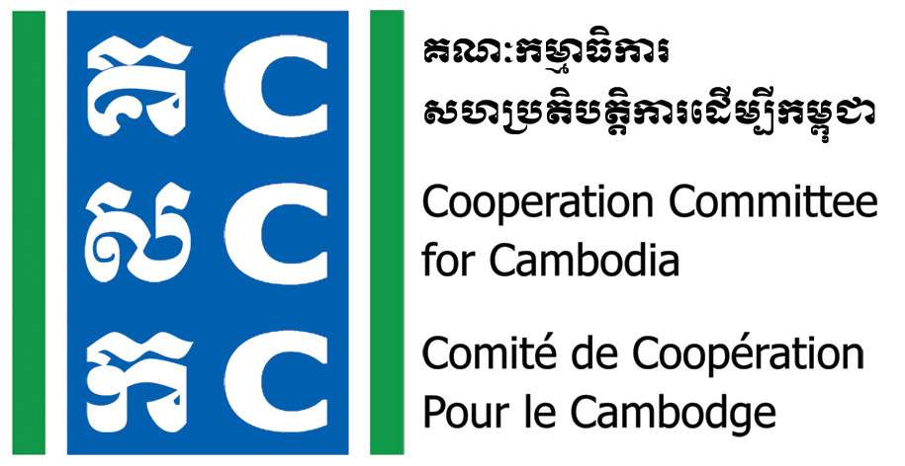

ទស្សនវិស័យៈ ការអភិវឌ្ឍប្រកបដោយនិរន្តរភាព និង ប្រជាធិបតេយ្យសម្រាប់ប្រទេសកម្ពុជា
Vision: Sustainable and democratic development for Cambodia

Do No Harm Training of Trainers
Date: 18-20 October 2023
Venue: Phnom Penh (TBC)

Background:
The Cooperation Committee for Cambodia (CCC) is a leading membership organization with 206 Local and International Non-Governmental Organizations (NGOs) in Cambodia.
Do No Harm and Conflict Sensitive Programming was hosted by CCC with the financial supports from Bread for the World (BfdW) who is concerned about the impacts of NGO’s work on local conflict. Do No Harm (DNH) is one of the key working approaches of CCC’s Governance Hub Program (GHP).
The goal of the DNH/CS phase 3 (01 January 2021-31 December 2023) is Civil Society Organizations in Cambodia are enabled to avoid negative impacts in their development programs.
Date & Venue:
- Date: 18-20 October 2023
- Time: 8:00am-05:00pm
- Venue: Phnom Penh (TBC)
Objective:
- To train Do No Harm core trainers in order to provide extension training on DNH in their own organizations or communities.
Participants:
- 02 Staff from each organization that plan to integrate/mainstream Do No Harm. One of them should be a Senior Management Team member of the organization.
- Individual who is interested and commit to join Do No Harm activities.
Note: The participants should have experiences in facilitation workshop/training and participated in previous Do No Harm Exposure Workshop.
Registration:
- Organization or individual who is interested in the Do No Harm ToT, please register in the link below by 5:00 PM on 06 October 2023.
- CCC will cover the cost of the 03 training days including venue, lunch and snack as well as training materials.
- Transportation, accommodation, and other expenses of the participants are the responsibility of their own organization/individual.

Further information, please contact:
Mr. Lav Bunrithy
DNH Specialist
Phone: 012 925 799
Email: bunrithy.lav@ccc-cambodia.org

Tentative Agenda:
Time | Activities | Facilitator
 | Day One
8:00 - 8:30 | Registration | CCC
8:30 – 9:00 | Welcome and Introduction | DNH Trainer
9:00 – 10:00 | Recall of Do No Harm concept | DNH Trainer
10:00 – 10:30 | Break
10:30 – 12:00 | Tools of Do No Harm | DNH Trainer
12:00 – 1:30 | Lunch
1:30 -3:00 | Facilitation skill and methodology | DNH Trainer
3:00 -3:30 | Break
3:30 – 5:00 | Preparation for DNH training  Wrap-up | DNH Trainer
 | Day Two
8:00 – 8:30 | Check-in and Reflect on Day 1 | DNH Trainer
8:30 – 10:00 | Practice on DNH training and feedback | DNH Trainer
10:00 – 10:30 | Break
10:30 – 12:00 | Practice on DNH training and feedback | DNH Trainer
12:00 – 1:30 | Lunch
1:30 – 3:00 | Practice on DNH training and feedback | DNH Trainer
3:00 – 3:30 | Break
3:30 – 5:00 | Preparation for DNH training  Wrap-up | DNH Trainer
 | Day Three
8:00 – 8:30 | Check-in and reflection on Day 2 | DNH Trainer
8:30 – 10:00 | Practice on DNH training and feedback | DNH Trainer
10:00 – 10:30 | Break
10:30 – 12:00 | Practice on DNH training and feedback | DNH Trainer
12:00 – 1:30 | Lunch
1:30 – 3:00 | Practice on DNH training and feedback | DNH Trainer
3:00 – 3:30 | Break
3:30 – 5:00 | Next steps  Course evaluation  Certification | CCC

Noted: CCC reserves the right to alter the agenda depending on time constraints and availability of resource persons.

