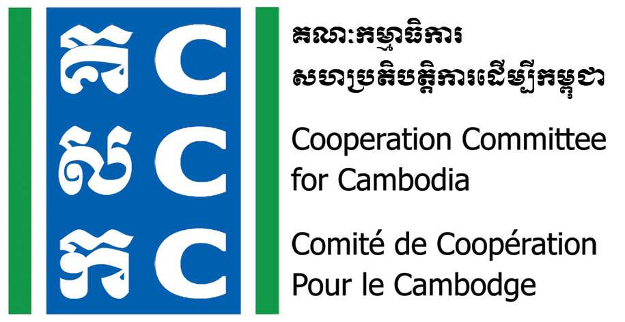

ទស្សនវិស័យៈ ការអភិវឌ្ឍប្រកបដោយនិរន្តរភាព និង ប្រជាធិបតេយ្យសម្រាប់ប្រទេសកម្ពុជា
Vision: Sustainable and democratic development for Cambodia

Do No Harm Community Practice Forum
14 August 2023

Background:
The Cooperation Committee for Cambodia (CCC) is a leading membership organization with 186 Domestic and International Non-Governmental Organizations (NGOs) in Cambodia.
Do No Harm and Conflict Sensitive Program (DNH/CS) is hosted by CCC with the financial supports from Bread for the World (BfdW) who is concerned about the impacts of NGO’s work on local conflict. DNH/CS is one of the key working approaches of CCC’s Governance Hub Program (GHP).
The Do No Harm Community of Practice Forum (DNH-CPF) is one of the activities of DNH/CS program organized twice a year to provide opportunity for sharing experiences among DNH/CS practitioners. The first DNH-CPF in 2023 will be organized on 14 August 2023 and expected there will be 70 participants to meet together as the specific objective below.
Objective:
- To share experiences in Do No Harm application among organizations and practitioners.
- To document good practices, challenges and lessons learnt from DNH practitioners and organizations.
Date & Venue:
- Date: 14 August 2023
- Time: 8:00 am - 05:00 pm
- Venue: Phnom Penh (location will be confirmed later)
Registration:
- Participation is free-of-charge
- Lunch, refreshment and materials will be provided by CCC
- Transport, per-diem and accommodation will be covered by participant’s organization
Please register online through the provided link latest by 5:00 PM on 04 August 2023.
https://www.ccc-cambodia.org/en/resources/event-calendar/2023-08-03/dnh-community-practice-forum
Agenda:
Time | Detailed Activity | Facilitator
8:00-8:30 | Registration | CCC
8:30-9:00 | - Welcome and Introduction | CCC
9:00-9:30 | Refresh on DNH framework/concept | DNHC member
9:30-10:00 | Update on Do No Harm and Conflict Sensitive Program  - Do No Harm videos  - Key Achievements and Lessons Learned | Mr. Lav Bunrithy  DNH Specialist, CCC
10:00-10:30 | Break
10:30-12:00 | Sharing experiences:  Practical implementation of DNH in Project/Program  - NGO Partner 1  - NGO Partner 2  - DNHC member  Guiding Questions  - What DNH did you apply? How?  - What changes (positive and negative) can you observe as a result of the DNH application?  - Do you have any challenges in applying DNH?  - What was your lessons-learnt?  - Q&A (60mn) | DNHC member
12:00-1:30 | Lunch Break
1:30-3:00 | Sharing topic related to DNH  Demonstration:  - Do No Harm cooking session (the art of DNH)  Group Discussion:  - What do you observe from this session?  - How it is related to Do No Harm?  - What can we learn from it? | Ms. Phuon Kongkea  DNHC member
3:00-3:30 | Break
3:30-4:45 | Next Step  - What did you learn from this forum? (1-2 point)  - What you will change or add in your project/program intervention?  - What support do you need (from DNHC team or others) in applying these learning? | DNHC member
4:45-5:00 | Summary and Closing | CCC/Representative of DNHC team

For more information, please contact:
Mr. Lav Bunrithy
Do No Harm Specialist
HP: 012 925 799
Email: bunrithy.lav@ccc-cambodia.org

Noted: CCC reserves the right to alter the agenda depending on time constraints and availability of speakers. CCC will upload all documents, photos, and key activities and ideas in CCC websites, and social media for public access.

