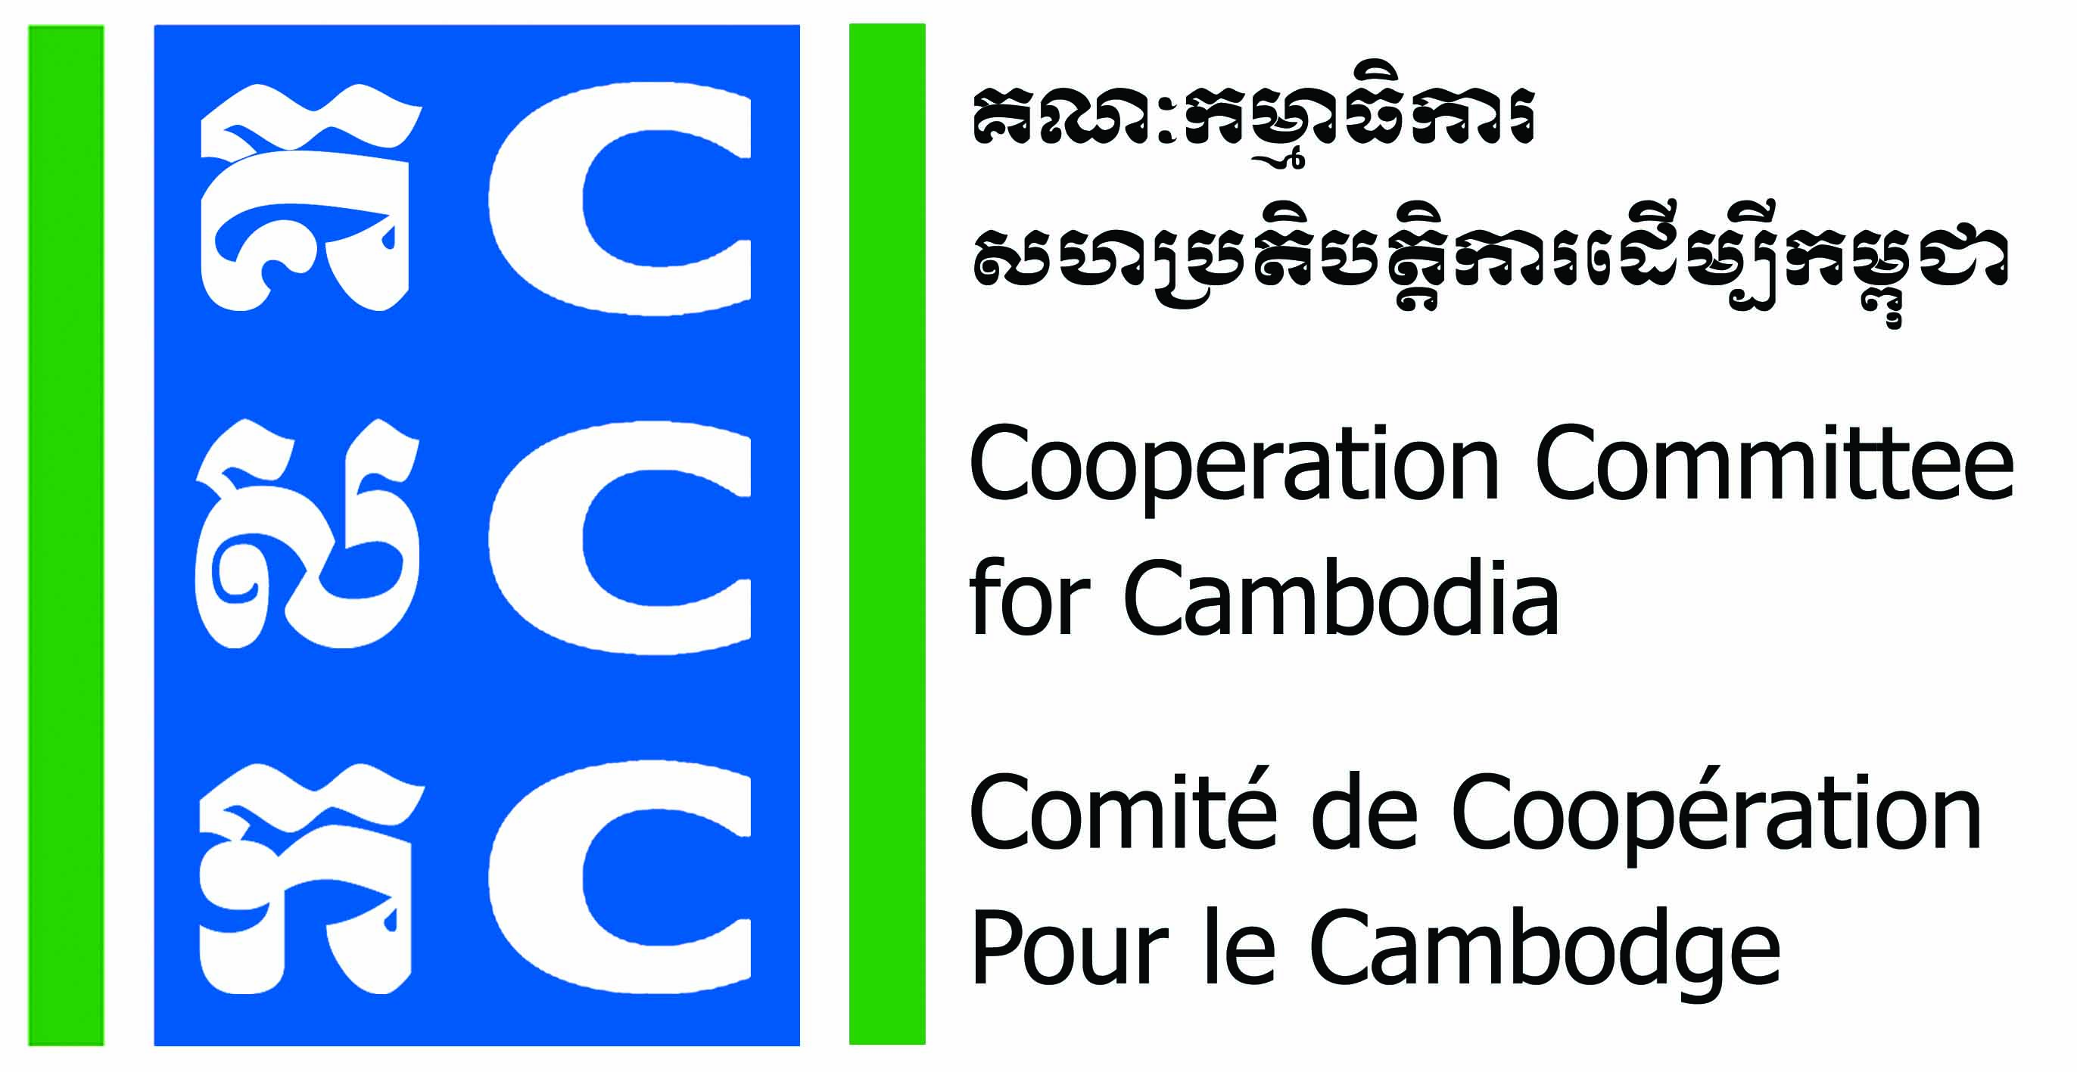
ទស្សនវិស័យៈ ការអភិវឌ្ឍប្រកបដោយនិរន្តរភាពសម្រាប់ប្រទេសកម្ពុជា
Vision: Sustainable development for Cambodia.

APPLICATION FORM
Do No Harm Training of Trainer
(24th – 26th August 2022)

- Please fill-in your personal information

- Applicant name: Sex: Male Female
- Position: Location:
- Date of Birth: Nationality:
- Phone contact: E-mail:
- Are you in Senior Management Level of the organization? Yes No
- Did you have experience as a Trainer or Facilitator? Yes No
If yes, And how long? ---------------Years

- Information about your organization

- Name of Organization:
- Organization’s address:
- Phone contact: Email:
- Organization’s status: CBO LNGO INGO
- Core work of organization:
1 | Health and Nutrition |  | 9 | Human right/Democracy
2 | HIV/AIDs |  | 10 | Rehabilitation
3 | Education/Training |  | 11 | Gender and Development
4 | Community Development |  | 12 | Child health/Child right
5 | Agriculture/Animal health |  | 13 | Credit/Saving
6 | Environment/Natural resource |  | 14 | Wash
7 | Disaster aid |  | 15 | Art and Culture
8 | Mine awareness raising |  | 16 | Others………………………………………….

- Please answer the question below:
(Please discus with your director about selecting program for application workshop and possible way of integration of DNH)

- Why are you interested in the DNH training? Or what do you expect it benefit for your organization?

- How will you apply DNH within your organization or community?

- After DNH training of trainer, when do you plan to conduct the application workshop for your organization? On what project/program?

Applicant’s Name:
Signature:
Date:

ទស្សនវិស័យៈ ការអភិវឌ្ឍប្រកបដោយនិរន្តរភាពសម្រាប់ប្រទេសកម្ពុជា
Vision: Sustainable development for Cambodia.

- Obligation of Applicant Organization
- Commit to nominate a focal person in your organisation and ensure consistency of staff participation throughout the project period, making an effort to include multiple staff in capacity building to facilitate back-up/redundancy and cross-training in staffing.
- Provide all relevant documentation, in the timeframe requested, to assist the consultant in preparing the coaching session. However, this is always only on a voluntary basis.
- Ensure that all relevant staff members as indicated in the learning needs form are present during the coaching session.
- Commit to participate in DNH Training of Trainer, coaching session and community practice forum that will be organised and facilitated by CCC.
- Commit to conduct DNH application workshop at its own organization
- Commit to applying the lessons learned from each coaching session.

- Registration:
Fill-in the above application form, sign, and submit to CCC by email (Bunrithy.lav@ccc-cambodia.org) by 5:00 PM on 12 August 2022.

Contact:
Mr. Lav Bunrithy
DNH Specialist
Phone: 012 925 799
Email: bunrithy.lav@ccc-cambodia.org

