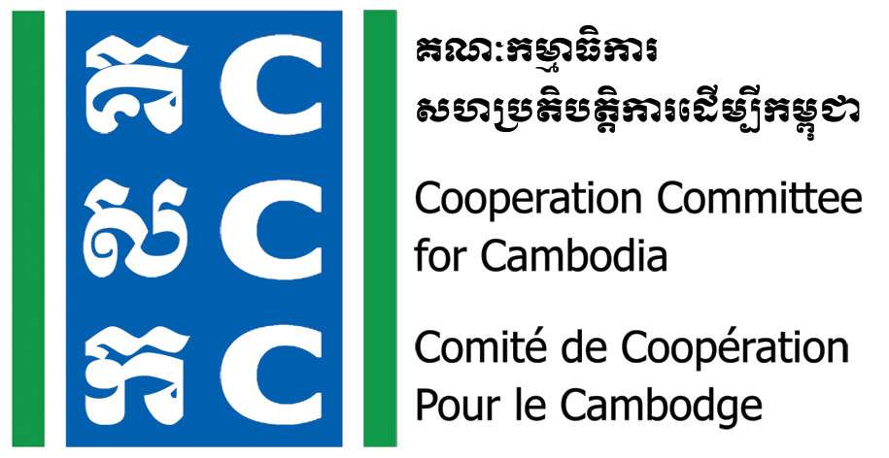

ទស្សនវិស័យៈ ការអភិវឌ្ឍប្រកបដោយនិរន្តរភាព និង ប្រជាធិបតេយ្យសម្រាប់ប្រទេសកម្ពុជា
Vision: Sustainable and democratic development for Cambodia

Do No Harm Training of Trainers
Date: 24-26 August 2022
Venue: Phnom Penh (TBC)

Background:
The Cooperation Committee for Cambodia (CCC) is a leading membership organization with 206 Local and International Non-Governmental Organizations (NGOs) in Cambodia.
Do No Harm and Conflict Sensitive Programming was hosted by CCC with the financial supports from Bread for the World (BfdW) who is concerned about the impacts of NGO’s work on local conflict. Do No Harm (DNH) is one of the key working approaches of CCC’s Governance Hub Program (GHP).
One of the DNH/CS phase 3 objectives is to train Do No Harm Training of Trainers so that they can organize Do No Harm training especially in their respective organization and/or community.
Date & Venue:
- Date: 24-26 August 2022
- Time: 8:00am-05:00pm
- Venue: Phnom Penh (TBC)
Objective:
- To train Do No Harm trainers.
Participants:
- 02 Staff from each organization that plan to integrate/mainstream Do No Harm. One of them should be a Senior Management Team member of the organization.
- Individual freelancer who is interested and commit to join future Do No Harm training.
Note: The participants should have experiences in facilitation workshop/training and participated in previous Do No Harm Exposure Workshop.
Registration and fee:
- Organization or individual who is interested in the Do No Harm ToT, please fill in the attached form in English or Khmer and submit to CCC via email: Bunrithy.lav@ccc-cambodia.org by 5:00 PM on 12 August 2022.
- CCC will cover trainers’ fee, venue, lunch and snack as well as materials for the 03 training days.
- Transportation, accommodation, and other expenses of the participants are the responsibility of their own organization/individual.

Further information, please contact:
Mr. Lav Bunrithy
DNH Specialist
Phone: 012 925 799
Email: bunrithy.lav@ccc-cambodia.org

Tentative Agenda:
Time | Activities | Facilitator
 | Day 01: 24 August 2022
8:00 - 8:30 | Registration | CCC
8:30 – 9:00 | Welcome and Introduction | DNH Trainer
9:00 – 10:00 | Recall of Do No Harm concept | DNH Trainer
10:00 – 10:30 | Break
10:30 – 12:00 | Tools of Do No Harm | DNH Trainer
12:00 – 1:30 | Lunch
1:30 -3:00 | Facilitation skill and methodology | DNH Trainer
3:00 -3:30 | Break
3:30 – 5:00 | Preparation for DNH training  Wrap-up | DNH Trainer
 | Day 02: 25 August 2022
8:00 – 8:30 | Check-in and Reflect on Day 1 | DNH Trainer
8:30 – 10:00 | Practice on DNH training and feedback | DNH Trainer
10:00 – 10:30 | Break
10:30 – 12:00 | Practice on DNH training and feedback | DNH Trainer
12:00 – 1:30 | Lunch
1:30 – 3:00 | Practice on DNH training and feedback | DNH Trainer
3:00 – 3:30 | Break
3:30 – 5:00 | Practice on DNH training and feedback  Wrap-up | DNH Trainer
 | Day 3: 26 August 2022
8:00 – 8:30 | Check-in and reflection on Day 2 | DNH Trainer
8:30 – 10:00 | Practice on DNH training and feedback | DNH Trainer
10:00 – 10:30 | Break
10:30 – 12:00 | Practice on DNH training and feedback | DNH Trainer
12:00 – 1:30 | Lunch
1:30 – 3:00 | Practice on DNH training and feedback | DNH Trainer
3:00 – 3:30 | Break
3:30 – 5:00 | Next Steps  Course evaluation  Certification | CCC

Noted: CCC reserves the right to alter the agenda depending on time constraints and availability of speakers. CCC will upload all documents, photos, and key activities and ideas in CCC websites, and social media for public access.

