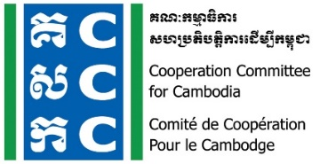

ទស្សនវិស័យៈ ការអភិវឌ្ឍប្រកបដោយនិរន្តរភាពនិងប្រជាធិបតេយ្យសម្រាប់ប្រទេសកម្ពុជា
Vision: Sustainable and democratic development in Cambodia

Agenda
CCC Members Bi-monthly Meeting

Meeting Date: 21 July 2022
Meeting Time: 8:00 am - 12:00 pm

Introduction
This 268th Bi-Monthly Members Meeting will be convened on 21 July 2022 at DK Meeting Center (St. 330, near Tuol Sleng Genocide Museum). Based on CCC’s Bylaw, member meeting is designed for participants who are Country Representatives/Executive Directors and Senior Leaders/Managers of CCC members to attend and share knowledge and experiences, the common concerns on the development challenges and other key issues of CCC members to be addressed together.

This meeting with CCC members to share and discuss among CCC members and update of CCC progress and plan as well as sharing of member works and other legal compliance impacts on civil society work. Therefore, it can be better response the current rapid changes, civil society environment and funding trends. This meeting is organized to achieve the following specific objectives:
- To welcome new members and haring of member works.
- To update the progress for the quarter progress of CCC work with members and plan.
- To update the current status of enabling space, legal policies and funding trending for CSOs.
- AOB

Meeting Agenda
Time | Key Agenda | Facilitator
8:00 am-8:30 am | Registration and networking among members | CCC and All
8:30 am | National anthem | MC
8:30 am-8:45 am | Welcome and opening remarks  - Update on CSO environment and legal space | Ms. Sin Putheary, Executive Director of CCC
8:45 am-9:45 am | To share and update from CCC members  - Presentation of TI Cambodia  - Presentation of Sre Khmer  Question &Answer  Award letter of new CCC members | - Mr. Pich Pisey, Executive Director of TIC (tbc)  - Ms. Nara Nou Alyny, Executive Director of Sre Khmer (tbc)
9:45 am -10:00 am | Coffee Break | All Participants
10:00 am -10:45 am | Sharing and update the progress of CCC work and plan  - Presentation of CCC progress and plan  Question &Answer | Ms. Luy Theary, Head of Program of CCC
10:45 am -11:50 am | Sharing and discussion on funding trend and opportunity for CSOs  - Presentation and discussion for funding trend and funding opportunity  Question &Answer | Mr. Norng Neat Norak, Head of Communication and Resource Mobilization  Ms.
11:50 am -12:00 pm | AOB, wrap-up and closing | Mr. Keng BunChhoeuth, Member of CCC ExCom, and Regional Manager of ERIKS, South-East Asia (tbc)
Solidarity lunch together at the venue

Note: - The meeting will be available interpret in Khmer and English languages. Organizers reserve the right to alter the agenda depending on time constraints and the availability of speakers. Some of the pictures and key ideas will be quoted and shared in public through the organizers’ social media and website. http://www.ccc-cambodia.org/en/resources/event-archives www.facebook.com/CCCsince1990 www.youtube.com/CCCambodia

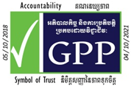
Partnerships for Sustainable and Democratic Development in Cambodia
www.ccc-cambodia.org
info@ccc-cambodia.org
T +855 (0)23 214 152
F +855 (0)23 216 009
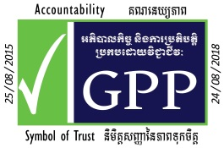
#9-11, Street 476,
Toul Tompoung 1, Chamkamorn
P.O. Box 885, Phnom Penh,
Cambodia

