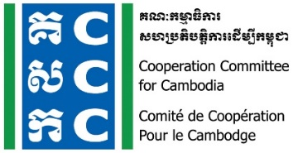

ទស្សនវិស័យៈ ការអភិវឌ្ឍប្រកបដោយនិរន្តរភាពនិងប្រជាធិបតេយ្យសម្រាប់ប្រទេសកម្ពុជា
Vision: Sustainable and democratic development in Cambodia

Agenda
Online CCC Members Meeting

Meeting Date: 23 September 2021
Meeting Time: 9:00 am - 12:00 pm

Link to Online Zoom Meeting: https://zoom.us/j/99572806321

Due to the outbreak of COVID‐19, CCC would like to shift Bi‐Monthly Members Meeting into Monthly Online Meeting, and this is the 265th meeting which will be conducted in order to share the most updated information about CCC and members, sharing and discussion on funding partners and their support, and other legal compliant for CSOs.

No. | Key Agenda | Key Points | Others
1 | Welcome and opening remarks  by Ms. Sin Putheary, Executive Director of CCC  (10 mn.) | Welcome and opening remarks
2 | How to Maintain the Civic Space and Promote Enabling Environment for CSOs  By Ms. Luy Theary of Head of Program, CCC  (20 mn. for sharing and 10mn for Q & A) | How to Maintain the Civic Space and Promote Enabling Environment for CSOs:  - Enabling environment for CSOs through the joint effort of CCC’s members  - Policy engagement at the national and regional levels  - How to strengthen organization and compliance with regulations related to CSOs.  Question &Answer
3 | Sharing from CCC members  By Mr. Srei Kosal, executive director of PADEK (TBC) and focal person for local humanitarian group  (20mn for presentation and 10mn for Q & A) | Share development approaches and humanitarian response for CSOs  Question &Answer
4 | Plenary: Funding Partners/Donors Relation  - Mr. …from Plant International  - Mr. …. from Action Aid Cambodia  - Ms. ….from PSI Cambodia  (35 mn. for sharing and 15mn for Q & A) | Plenary sharing and discussion on funding partners for CSOs in Cambodia  - Background of funding  - Criteria  - Opportunities and key to engagement funding partners  Question &Answer
5 | AOB, wrap up and closing  - Representative of CCC ExCom  (20 minutes) | Close discussion for CCC member only and closing  - Next meeting
Noted: There will be simultaneous interpretation for English and Khmer languages. Organizers reserve the rights to alter the agenda depending on time constraint and availability of speakers. Some of pictures and key ideas will be quoted and shared in public through organizers’ social media and website. http://www.ccc-cambodia.org/en/resources/event-archives
www.facebook.com/CCCsince1990 www.youtube.com/CCCambodia

Partnerships for Sustainable and Democratic Development in Cambodia
www.ccc-cambodia.org
info@ccc-cambodia.org
T +855 (0)23 214 152
F +855 (0)23 216 009
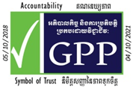
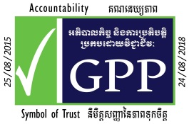
#9-11, Street 476,
Toul Tompoung 1, Chamkamorn
P.O. Box 885, Phnom Penh,
Cambodia

