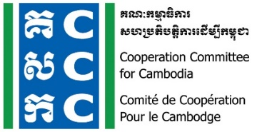

ទស្សនវិស័យៈ ការអភិវឌ្ឍប្រកបដោយនិរន្តរភាពនិងប្រជាធិបតេយ្យសម្រាប់ប្រទេសកម្ពុជា
Vision: Sustainable and democratic development in Cambodia

Agenda
Online CCC Members Meeting

Meeting Date: 29 July 2021
Meeting Time: 9:00 am - 12:00 pm
Online Meeting (link will later inform)

Due to the outbreak of COVID‐19, CCC would like to shift Bi‐Monthly Members Meeting into Monthly Online Meeting, and this is the 264th meeting which will be conducted in order to share the most updated information about CCC and members, discussion on development issues, research result, and other legal compliant for CSOs.

No. | Key Agenda | Key Points | Others
1 | Welcome and opening remarks  by Ms. Sin Putheary, ED of CCC  (25 mn.) | Welcome and opening remarks
2 | Update legal compliant and response actions  By Mr. Ry Sovanna, Legal and Policy Manager of CCC  (30 mn. for sharing) | Update about CCC and other related work to civic space and legal compliant:  - Some regulations related to COVID-19, practices and response action  - Taxation, Accounting and Auditing, and Labor Law
3 | Sharing from new members:  By Mr. Cheu Sokkin, representative from Hold Dream Center, and Mr. Nop Vy, Executive Director of CambodJA  (50mn for presentation and 10mn for questions and answers) | Share development approaches and work under the current context:  - Hold Dream Center (TBC),  - CambodJA
4 | Sharing research result from CCC member:  Mr. Aok Sam Eath, Project Manager of Live and Lean Cambodia  (20mn. presentation and 10mn. for question and answer) | Share Research Result on:  - functions, climate resilience and biodiversity conservation within the Stung Siem Reap
5 | AOB, wrap up and closing  (25 minutes) | AOB and Wrap Up  - Next meeting
Meeting minutes and relevant documents from previous meetings: https://drive.google.com/drive/u/0/folders/1wgXEgYt94iiGPDfABYQ9yKyBVGOg-2jJ

