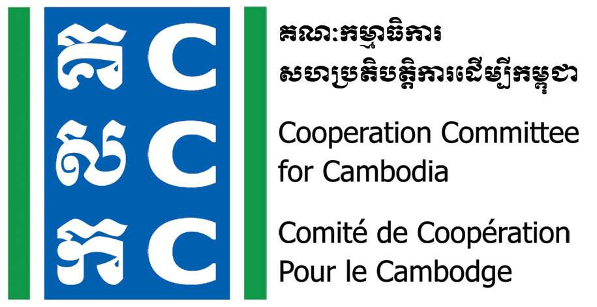

ទស្សនវិស័យៈការអភិវឌ្ឍប្រកបដោយនិរន្តរភាពនិងប្រជាធិបតេយ្យសម្រាប់ប្រទេសកម្ពុជា
Vision: Sustainable and democratic development for Cambodia

Summary of Key-asks, Outcome Statement, Next Action
From
Virtual Discussion with Accounting and Auditing Regulator
Date: June 15th, 2021

CCC coordinated key-asks from civil society organizations through its Finance and Taxation Technical Working Groups meeting. These key-asks were brought forward by CCC’s Executive Director during the virtual discussion held on June 15th, 2021 on the implementation of obligations stipulated in the Law on Accounting and Auditing for not-for-profit entities. The discussion was chaired by H.E Bou Tharin, Secretary General of Accounting and Auditing Regulator

Key-Asks:

- Extension period of at least one more year for civil society to develop accounting and auditing capacity and partnership, prior to enforcement of article 6 in sub-decree about the provisional fines (in cash) for violating the law on accounting and auditing.
- Taking out the provision fund section from the financial report because this is extremely difficult for civil societies to estimate due to they rely heavily on donor funding, many of which do not allow to use fund as contingency or record fund as for provision purpose (they require specific purpose of fund usage). In addition, there will be huge vague in such funding forecast.
- Changing the record on impairment from being as an obligational to optional requirement, by determining assets as historical cost with the record of this impairment under “disclosure part” to align with the nature of not-for-profit entities.
- Consider all civil societies as new operational unit with non-retroactive effect for cases that any accounting standard to be decided by AAR for civil societies to implement due to the fact that they, the civil societies had not used any particular accounting standard.
- Simplify some vocabularies used in accounting standards for not-for-profit entities which are not commonly practiced in Cambodia.

The Response from H.E Bou Tharin, Secretary General of Accounting and Auditing Regulator:

- It has been more than two years that the government granted extension period for civil societies to prepare for the full implementation and compliance of the law on accounting and auditing (Samdech Akka Moha Sena Padei Techo HUN SEN, Prime Minister of the Kingdom of Cambodia had endorsed a letter from MoI requesting this extension, in October 2018.)
- Thus, AAR will not consider accepting civil society’s request for the delay of this provisional fines for not compliance with the requirements from the Law of Accounting and Auditing
- AAR acknowledged that it has been no awareness raising or capacity building on the requirements from the law to civil society. Thus, the body will issue a​ circular to help explain on the technical process of implementation requirements. Series of capacity building will be followed.

Next Action Points:

- CCC is waiting for the circular and then will coordinate for the capacity building on the technical requirements from the Law on Accounting and Auditing to civil society organization.

