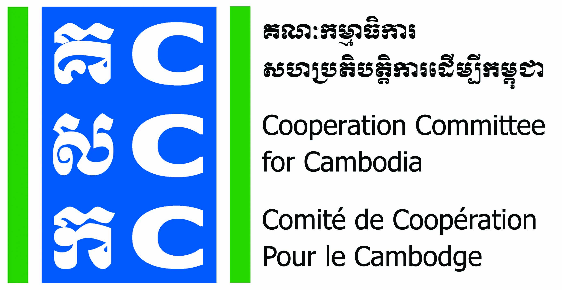
ទស្សនវិស័យៈ ការអភិវឌ្ឍប្រកបដោយនិរន្តរភាពសម្រាប់ប្រទេសកម្ពុជា
Vision: Sustainable development for Cambodia

CALL FOR PARTICIPATION

Do No Harm Application Workshop

- Background information
The Cooperation Committee for Cambodia (CCC) is a leading membership organization in Cambodia. December 2019, CCC has 208 International and Local NGOs as members and other networking with NGOs and Associations in 15 provinces, working on different development sectors in the country. CCC has been playing a unique role since 1990 in strengthening cooperation professionalism accountability governance of CSOs for effectively and innovatively responding to development challenges in Cambodia.
Do No Harm and Conflict Sensitive Program (DNH-CSP) has been implemented by Cooperation Committee for Cambodia (CCC) since 2015 with financial support from Bread for the World (BfdW). DNH is one of the key working approaches of CCC’s Governance Hub Program (GHP) 2017-2021. And, the second phase of DNH-CSP is a 3-year project period from 1 September 2017 to 31 August 2020.
Goal of the program: CSOs in Cambodia deliver their programs with conflict sensitivity so as to do no harm in the community.
Objective of the program: By 2020, NGOs in Cambodia make changes to their project plans, their implementation and their monitoring systems according to the DNH framework.
Do No Harm Cambodia (DNHC) is a working group formed in 2014 by trainers and NGOs supported by BfdW who are concerned about the impacts of NGO work on local conflict. DNHC team is formally hosted by CCC. Currently, there are 18 members of DNHC team (9 women) have facilitated DNH trainings and provided coaching to 90 NGOs including Application and Exposure Workshops.
Since the project started in 2017, 90 organizations were trained on DNH concept through participating in DNH Exposure Workshop for 2-day. About 70% of them impressed that Conflict Analysis (CA), identification of Dividers and Connectors (D&C), Unpack Project, Resource Transfers (RT) and Implicit Ethical Messages (IEM) steps help them to predict the unintended negative and positive impacts. Reflecting to the DNH concept, most of participants have individual changes by trying to minimize negative effects through their behaviors and actions.
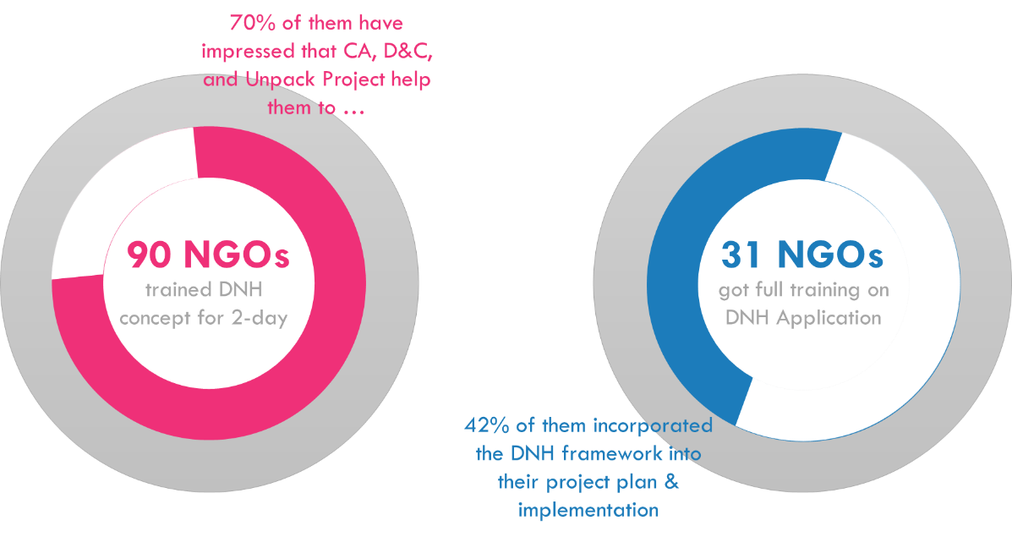
31 of 90 organizations were trained for another 3-5 days through DNH Application Workshop and DNH coaching on how to incorporate DNH framework in their project plan, implementation and monitoring. From the general interaction with the trained organizations, 94% of 31 organizations who completed DNH Application Workshop were able to identify new approaches of their project’s implementation through practical exercise. 42% among 31 organizations have incorporated the DNH framework into their project proposal and project plan, and 50% of them transferred DNH concept to the community leaders through meeting and training at the target community.

Base on the DNH satisfaction survey and DNH Community Practice Forum, the participants are aware of their intervention can be a part of Dividers or Connects in the community. So, they have requested to expand DNH concept and principles among NGOs community in Cambodia because DNH is the good tool to ensure the success of community as well as to motivate them to apply DNH and Conflict Sensitivity.
By seeing the demands of NGOs on the Do No Harm Training, CCC would like to call for participant to the Do No Harm Application Workshop for 5 days.
- Objective
Participants understand what DNH is, and how the various concepts work together. They can identify Dividers and Connectors in their context and generate programming options to improve their impacts on Dividers and Connectors.
- Topic of the course

- Introduction to DNH program and program history
- Collaborative Leaning Methodology
- The 6 Lessons of the DNH Program (DNH Framework)
- 7 Steps of DNH process
  - Step 1: Understand the Context of Conflict
  - Step 2: Analyze Dividers and sources of tension in the context
  - Step 3: Analyze Connectors and local capacities for peace in the context
  - Step 4: Understand the critical details of the intervention
  - Step 5: Analyze the intervention’s impact on Dividers and Connectors through its Actions and its staff Behavior
  - Step 6: Generate programming Options
  - Step 7: Test options and redesign the intervention
- Integrating DNH into the project cycle

- Methodology
DNH Application Workshop was designed for face to face meeting or online meeting (optional), there are 2 main methodology will be used during the workshop:
- Collaborative learning methodology
- Case study teach method (CSTM)
Note: This workshop offers participants the opportunity to apply the skills they have learned to their own programs. Participants should prepare for this workshop by bringing with them a program synopsis, or proposal. If this is a multi-organization workshop, each organization should prepare a single proposal. In a single organization workshop, multiple projects can be prepared, and participants can be divided into project teams.
- Recruitment
- The DNH Application Workshop targets a maximum of 5 NGOs who are a member of CCC and NGO provincial network
- Selection criteria, process and timeline will be jointly designed by CCC and DNHC team
- NGOs who applied for the DNH Application Workshop will be selected by recruitment committee

- Scholarship for the DNH Application Workshop
CCC will financially support on DNH trainer from DNHC team to organize DNH Application Workshop for 5 days at applicant organization. The project funded by Bread for the World (BfdW).
For logistic, materials, meeting room and per-diem participants will be covered by applicant organization.
- Timeline
The DNH Application Workshop for each individual NGOs will be conducted in between 10 August 2020 to 31 October 2020.
- Obligation of Applicant Organization
- Commit to nominate a focal person in your organisation and ensure consistency of staff participation throughout the project period, making an effort to include multiple staff in capacity building to facilitate back-up/redundancy and cross-training in staffing.
- Provide all relevant documentation, in the timeframe requested, to assist the consultant in preparing the coaching session. However, this is always only on a voluntary basis.
- Commit to conduct DNH application workshop at its own organization
- Ensure that all relevant staff members as indicated in the learning needs form are present during the coaching session.
- Commit to participate in DNH coaching session and community practice forum that will be organised and facilitated by CCC.
- Commit to applying the lessons learned from each coaching session.
- Deadline of Registration:
For interested NGOs, please fill-in application form and send to CCC before 30 July 2020.

Contact:
- Ms. Luy Theary
Capacity Development Manager
HP: 012 33 90 27 | 016 65 90 80
E: theary.luy@ccc-cambodia.org
- Mr. Sok Neng
Learning Specialist
HP: 012 266 234 | 098 777 905
E: neng.sok@ccc-cambodia.org

