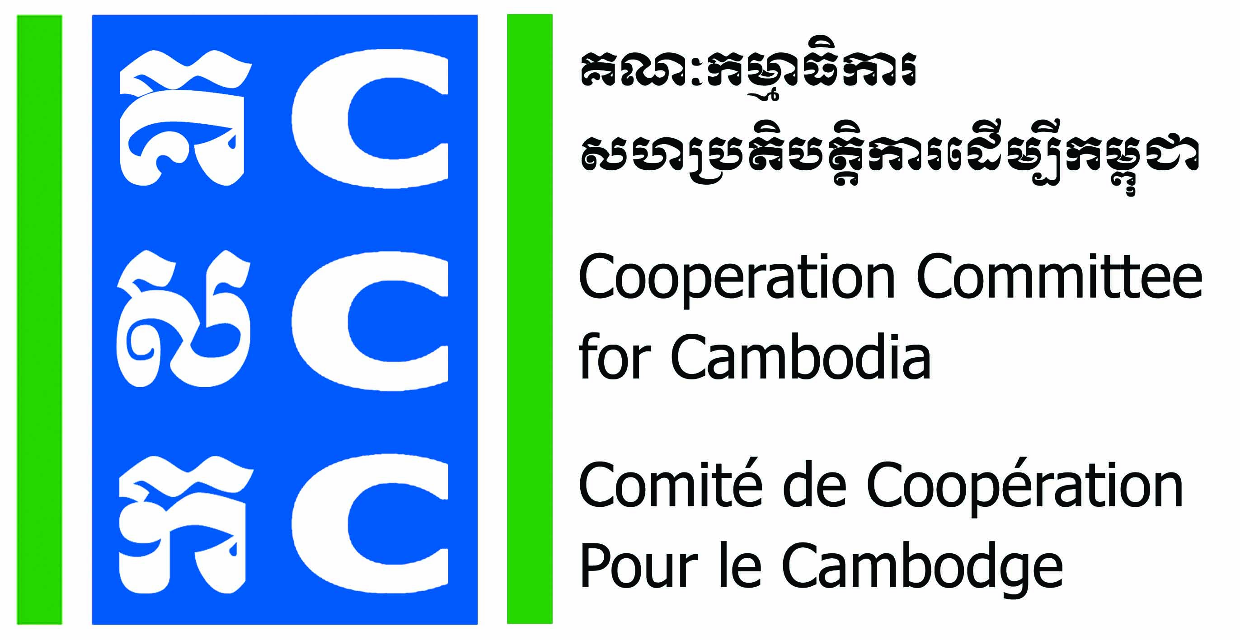
ទស្សនវិស័យៈ ការអភិវឌ្ឍប្រកបដោយនិរន្តរភាពសម្រាប់ប្រទេសកម្ពុជា
Vision: Sustainable development for Cambodia.

APPLICATION FORM
Do No Harm Application Workshop

This workshop will provide to organizational level, not individual level. Do No Harm Application Workshop will provide to all staff of the organization.
- Please fill-in your personal information

- Full name: Sex: Male Female
- Position: Location:
- Date of Birth: Nationality:
- Phone contact: E-mail:
- Are you in Senior Management Level of the organization? Yes No

- Information about your organization

- Name of Organization:
- Organization’s address:
- Phone contact: Email:
- Organization’s status: CBO LNGO INGO
- Core work of organization:
1 | Health and Nutrition |  | 9 | Human right/Democracy
2 | HIV/AIDs |  | 10 | Rehabilitation
3 | Education/Training |  | 11 | Gender and Development
4 | Community Development |  | 12 | Child health/Child right
5 | Agriculture/Animal health |  | 13 | Credit/Saving
6 | Environment/Natural resource |  | 14 | Wash
7 | Disaster aid |  | 15 | Art and Culture
8 | Mine awareness raising |  | 16 | Others………………………………………….

- Please answer the question below:
(Please discus with your director about selecting program for application workshop and possible way of integration of DNH)

- Why are you interested in the DNH training? Or what do you expect it benefit to your organization?

- How will you apply DNH within your organization or community?

- When do you plan to conduct a 5 days DNH Application Workshop at your own organization?

Applicant’s Name:
Signature:
Date:

