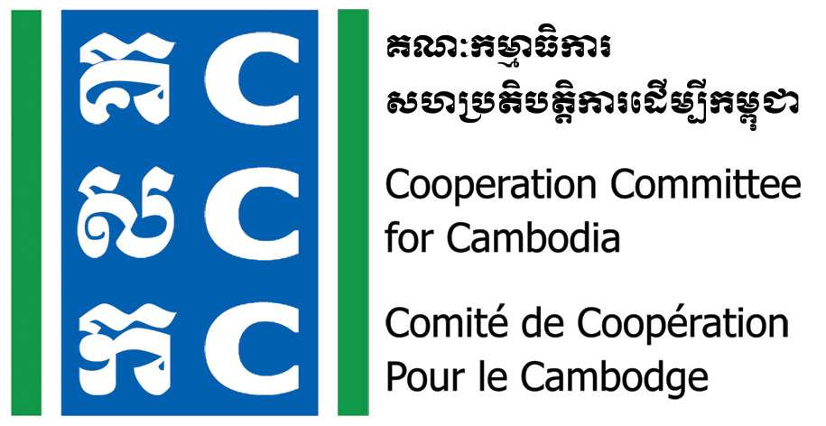

ទស្សនវិស័យៈ ការអភិវឌ្ឍប្រកបដោយនិរន្តរភាពសម្រាប់ប្រទេសកម្ពុជា
Vision: Sustainable development for Cambodia

M<<M<M<m<

Application for Scholarship
CCC has gotten financial support from Bread for the World (BfdW) since 2015 to implement a project called “Do No Harm & Conflict Sensitive Programming”. Do No Harm Training of Trainer is a part of program activity. The applicant who will get a scholarship, s/he must conduct DNH Application Workshop and facilitate DNH process at own organization with support from DNHC trainer, please see more details on the responsibility of Applicant in Learning Agreement. DNH framework will be developed after the Application Workshop for the implementation of the applicant organization.
Applicant’s name: Sex: Position:
Phone Contact: Email:
Organization (Full name):
Organization’s Contact:

I am applying for scholarship of Do No Harm Training of Trainers for 5 days from 17th to 21st September 2018.
Requested Scholarship Amount: Full scholarship Half scholarship
Other Amount:
Reason:

I certify that the statements herein are true to the best of my knowledge and grant my permission for the information contained herein to be shared with the scholarship selection committee(s) and scholarship donor(s).

Applicant’s signature: Date:

I, director of the organization, will support the applicant to conduct DNH Application Workshop and facilitate the application of DNH process in the organization.

Director’s signature: Date:

For Scholarship Committees Only
Amount Awarded: _______________________Date Awarded: _________________________

