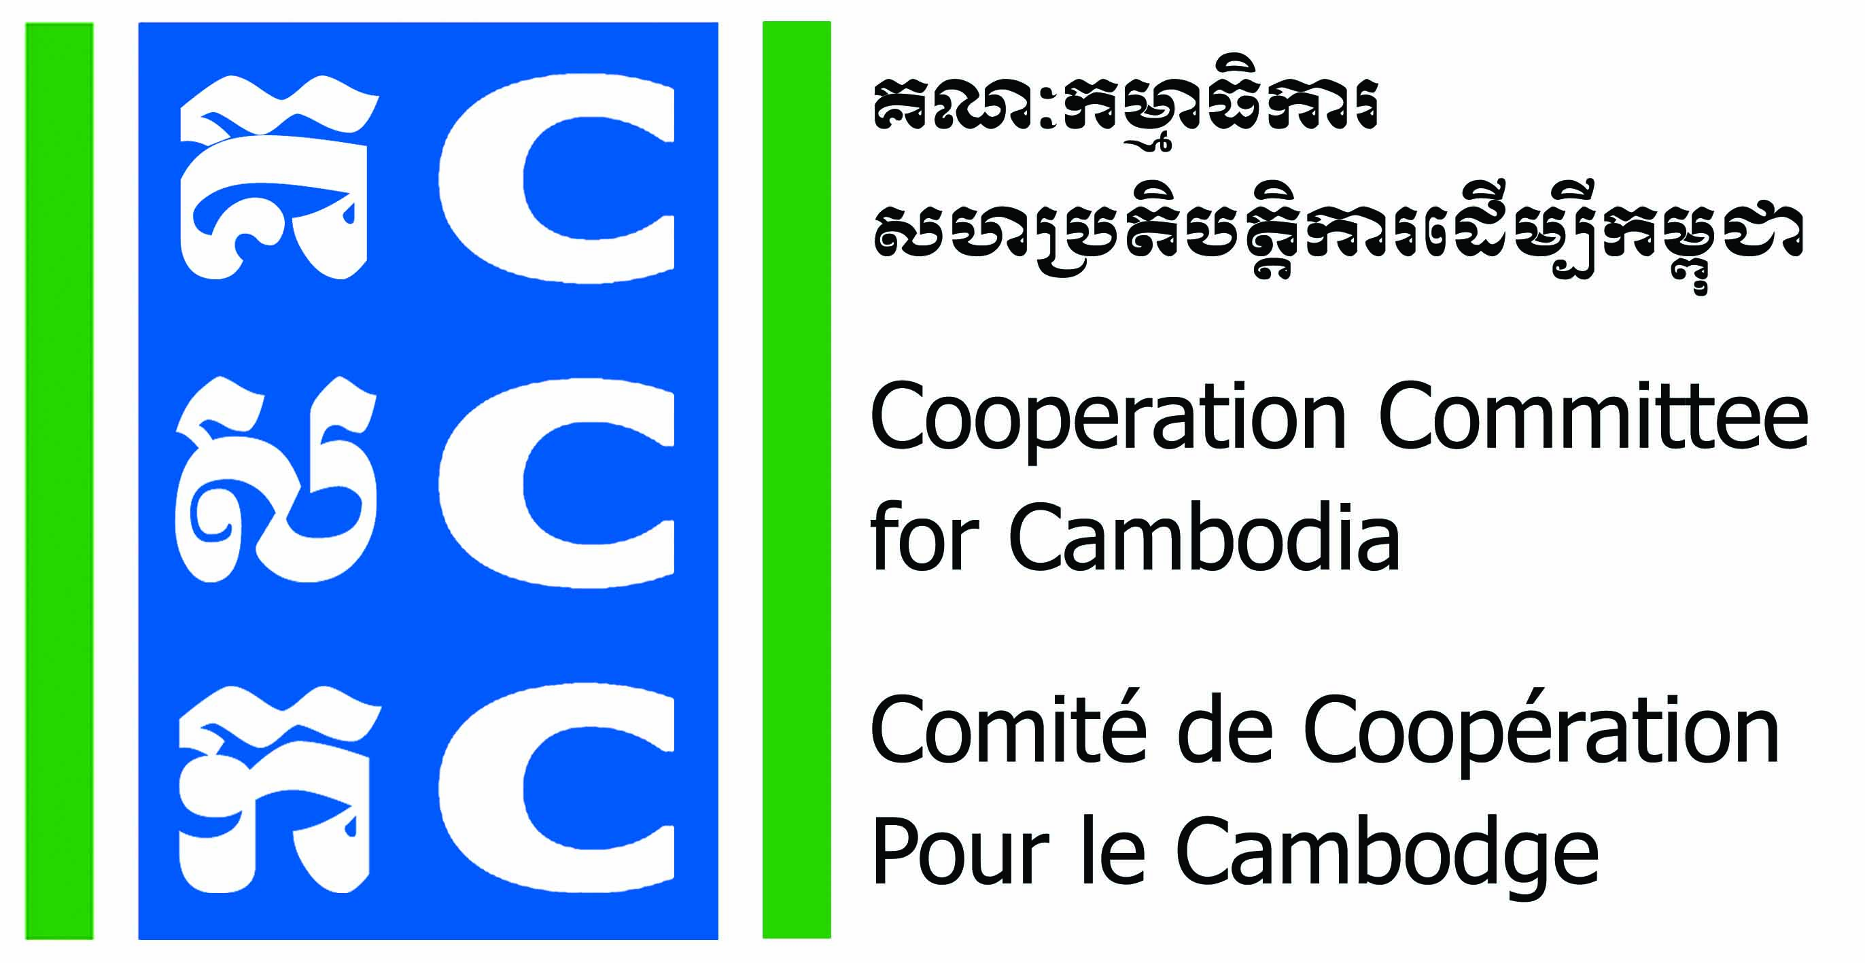
Logo of Partner

Training and Advisory Service in Do No Harm (DNH) to
Partner Organizations in Cambodia
(Sep 2019-Aug 2020)
LEARNING AGREEMENT
This learning agreement is voluntarily participated in by the NGO’s partner of BfdW signing below and CCC. The objective of this learning agreement is to strengthen the roles and responsibilities of Partner Organizations and CCC to be effective and joint responsible and accountable to achieve the objectives and indicators of the Do No Harm and Conflict Sensitive Programming (DNH-CSP) in 12 months (Sep 2019-Aug 2020).
By signing this learning agreement both parties, CCC and Partner Organization, agreed to the following principles and responsibilities:
CCC Responsibilities:
- Discuss and clarify the partner organisation’s expectations and learning needs to the DNH’s consultancy.
- Ensure any Confidential Information will not be shared with anyone outside of CCC and DNHC team.
- Design the coaching processes to ensure that the learning needs are achievable within the allocated time.
- Design and facilitate DNH Training of Trainer to selected Partner Organization in developing action plan to conduct application workshop at its own Partner Organization.
- At each coaching session, CCC will support the Partner Organization in developing a learning application plan to internalise all learning taking place on the individual as well as the organisational level.
- Follow up on the learning application plan in a further coaching session and report to BfdW.
- Design and facilitate a Community Practice Forum to allow for selected Partner Organizations to exchange their experiences, lessons learned and best practices according to specific topics.
Partner Organization Responsibilities:
- Commit to nominate a focal person in your organisation and ensure consistency of staff participation throughout the project period, making an effort to include multiple staff in capacity building to facilitate back-up/redundancy and cross-training in staffing.
- Provide all relevant documentation, in the timeframe requested, to assist the consultant in preparing the coaching session. However, this is always only on a voluntary basis.
- Ensure that all relevant staff members as indicated in the learning needs form are present during the coaching session.
- Commit to participate in DNH Training of Trainer, coaching session and community practice forum that will be organised and facilitated by CCC.
- Commit to conduct DNH application workshop at its own organization
- Commit to applying the lessons learned from each coaching session.

CCC appreciates that circumstances change and Partner Organization who initially agreed to commit to their responsibilities as set out above are not always able to engage consistently for one reason or another. If CCC identifies a pattern of non-engagement reflecting that the Partner Organization is unable, due to other institutional needs or priorities, to participate in the DNH-CSP, CCC will discuss this with the Partner Organization’s focal person. If the issue continues, CCC will notify and consult with BfdW, on determining whether the assistance should be suspended or discontinued.
If at any point the Partner Organization is dissatisfied with CCC’s performance under this agreement, they are encouraged to make this known to BfdW’s Southeast Asia and Pacific Unit, Judith Schüle, at judith.schuele@brot-fuer-die-welt.de.
The parties enter this agreement with the intent and expectation that they will be able to fully satisfy their obligations, each to the other.
This learning agreement has been discussed and agreed upon and signed.

For CCC: Partner Organization’s Name:
Agreed by: Agreed by:

______________________________ ________________________________
Mr. Soeung Saroeun Name:
Executive Director Position:
Date: ________________________ Date: __________________________

