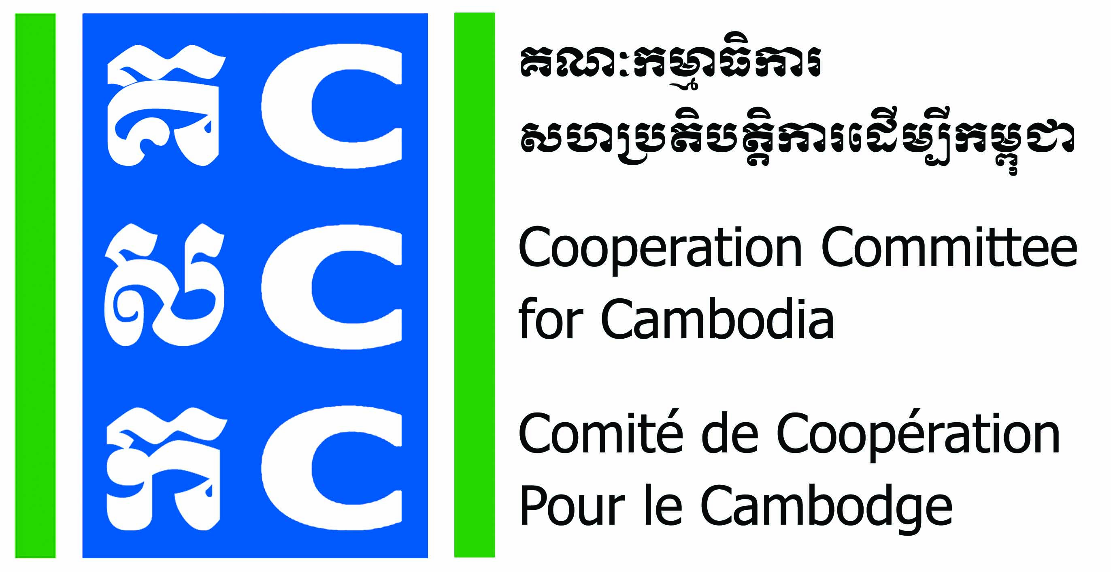
ទស្សនវិស័យៈ ការអភិវឌ្ឍប្រកបដោយនិរន្តរភាពសម្រាប់ប្រទេសកម្ពុជា
Vision: Sustainable development for Cambodia.

APPLICATION FORM
Do No Harm Training of Trainer
Diakonia Center, (9th – 13th September 2019)

- Please fill-in your personal information

- Applicant name: Sex: Male Female
- Position: Location:
- Date of Birth: Nationality:
- Phone contact: E-mail:
- Are you in Senior Management Level of the organization? Yes No
- Did you have experience as a Trainer or Facilitator? Yes No
If yes, And how long? ---------------Years

- Information about your organization

- Name of Organization:
- Organization’s address:
- Phone contact: Email:
- Organization’s status: CBO LNGO INGO
- Core work of organization:
1 | Health and Nutrition |  | 9 | Human right/Democracy
2 | HIV/AIDs |  | 10 | Rehabilitation
3 | Education/Training |  | 11 | Gender and Development
4 | Community Development |  | 12 | Child health/Child right
5 | Agriculture/Animal health |  | 13 | Credit/Saving
6 | Environment/Natural resource |  | 14 | Wash
7 | Disaster aid |  | 15 | Art and Culture
8 | Mine awareness raising |  | 16 | Others………………………………………….

- Please answer the question below:
(Please discus with your director about selecting program for application workshop and possible way of integration of DNH)

- Why are you interested in the DNH training? Or what do you expect it benefit for your organization?

- How will you apply DNH within your organization or community?

- After DNH training of trainer, when do you plan to conduct the application workshop for your organization? On what project/program?

Applicant’s Name:
Signature:
Date:

ទស្សនវិស័យៈ ការអភិវឌ្ឍប្រកបដោយនិរន្តរភាពសម្រាប់ប្រទេសកម្ពុជា
Vision: Sustainable development for Cambodia.

DETAILED INFORMATION

Do No Harm Training Program

- Training fees
The cost of the training is US$ 250.00 per person for 5 days training (including lunch, coffee break and training material)
BfdW will pay full fees of the training to the applicant NGO from selected BfdW partner.
- Applicant criteria
There are 2 types of applicant who is eligible to participate in Do No Harm Training of Trainers:
- Non-governmental organization (NGO)
- There are only 2 staff per NGO, at least there is one staff in senior management level and another is a program staff. However, the training is preferred the applicant who is in the senior management level of the organization.
- At least 3-year experience in trainer
- High commitment to attend the full training course
- High commitment to conduct DNH training at your own organization or transfer knowledge to community and partners after the course completion
- Individual (Freelance consultant)
- Trainers who is willing to facilitate DNH processes in future as part of the DNHC team
- High commitment to attend the full training course

- Scholarship for the training program course
Eligible organization is only BfdW partners have located in Cambodia. However, the scholarship is limited for 5 organizations (2 staff per NGO) only per year.
The scholarship included ToT training for 5 days, service fee for DNHC trainer to co-facilitate Application workshop for 5 days, and service fee for coaching and mentoring for 6 days per NGO. In total amount is up to 4,000$ per organization.

- Obligation of Applicant Organization
- Commit to nominate a focal person in your organisation and ensure consistency of staff participation throughout the project period, making an effort to include multiple staff in capacity building to facilitate back-up/redundancy and cross-training in staffing.
- Provide all relevant documentation, in the timeframe requested, to assist the consultant in preparing the coaching session. However, this is always only on a voluntary basis.
- Ensure that all relevant staff members as indicated in the learning needs form are present during the coaching session.
- Commit to participate in DNH Training of Trainer, coaching session and community practice forum that will be organised and facilitated by CCC.
- Commit to conduct DNH application workshop at its own organization
- Commit to applying the lessons learned from each coaching session.

* Please fill-in the Scholarship Form, if you want to apply for scholarship.
- Document requirement
- Application Form
- Learning Agreement
- Scholarship Request Letter

- Background information
The Cooperation Committee for Cambodia (CCC) is a leading membership organization with 175 Local and International Non-Governmental Organization (NGOs) in Cambodia. CCC has been playing a unique role since 1990 in strengthening cooperation professionalism accountability governance of CSOs for effectively and innovatively responding to development challenges in Cambodia.
Do No Harm Cambodia (DNHC) is a working group formed in 2014 by trainers and NGOs supported by Bread for the World (BfdW) who are concerned about the impacts of NGO work on local conflict.
Do No Harm (DNH) fits well with CCC as it is one of the key working approaches of CCC's Governance Hub Program (GHP) 2017-2021. CCC will continue introducing DNH approach to its members and BfdW partners.
Do No Harm Training of Trainers (ToT) will need two staff members (one at senior level) from each NGO which plan to do the full course on DNH for 5-day. The trained staff will be equipped to facilitate the DNH process within their own NGO, reducing ongoing reliance on the DNHC team. The trained staff will co-facilitate the DNH Application Workshop with a DNHC trainer, thereby building the NGOs’ internal DNH capacity while still receiving external guidance.

- Registration:
Fill-in application form and send to CCC before 26 August 2019.

Contact:
Ms. Luy Theary
Capacity Development Manager
HP: 012 33 90 27 | 016 65 90 80
E: theary.luy@ccc-cambodia.org

