34th HR Learning Forum 2017

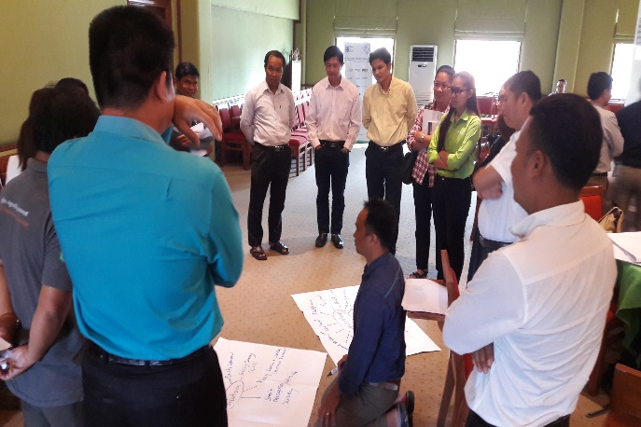 |  | 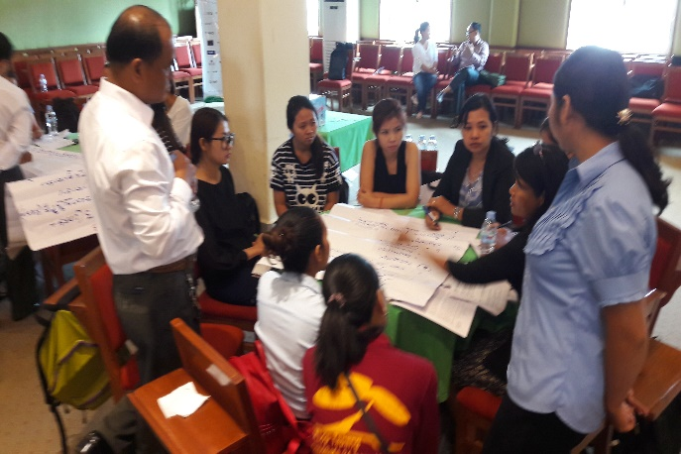 |  | 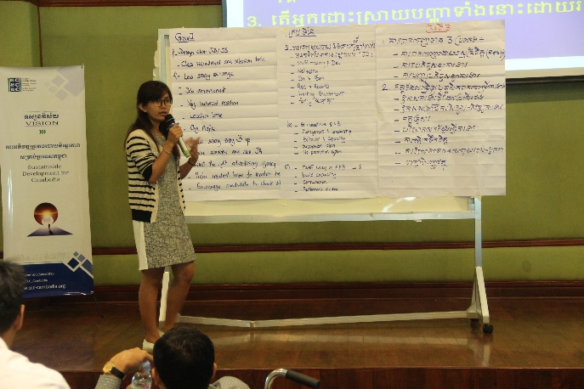

Objectives of the HR Learning Forum
• To strengthen participant’s internal policy to comply with the relevant laws of Cambodia
• To promote the understanding of participants on the Legal compliance on Employment Terms and Condition
• To create a learning and sharing environment and build a stronger network of HR practitioners among CSOs community.
Expected outputs
• The participants will be aware more on the Legal compliance on Employment Terms and Condition
• The participants will have better understanding related to Labor law in Cambodia (especially staff benefits related to the Labor law)
• Practitioner participants will have more chance to learn, share, and build up more relationship among people who have same interest from similar fields.
Target Participants
This HR learning forum is offered to a maximum of 80-100 participants from CCC members and non-members organizations who are HR practitioners and other interested NGOs. Each participant should be assigned by the senior management of their organization and committed to apply what has been learned from the forum to their organization. Participants from non‐CCC member are welcomed but are subjected to pay attendance fee as stated in the CCC Policy to support the Learning Forum’s logistic arrangement.

Agenda | Slide Presentation |Minute | Photo | Attendance List

