

Partnership Interns

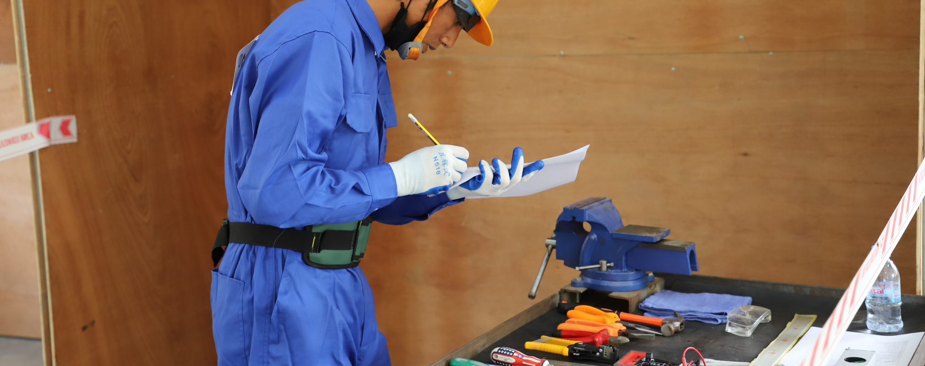




We are a leading organisation for the implementation of international development
projects. We promote inclusive economic, social and ecological development to make an effective contribution towards sustainable and widespread prosperity in developing and emerging economies.

Swisscontact - the Swiss Foundation for Technical Cooperation is an independent, non-profit foundation based in Zürich, founded in 1959 by leading figures from the Swiss private sector and Swiss universities. It is exclusively involved in international development, active in more than 38 countries with 120 programmes with more than 1,000 staff members. Swisscontact has been present throughout South-East Asia for more than 30 years. Swisscontact has been operating in Cambodia since 2013, establishing its office in the country in April 2016.

To support us in the project activities we are looking for a motivated Partnership Interns to be a part of our team.
- Partnership Interns
Employment start: mid June 2026
Number of people: 2
Place of work: Phnom Penh
Duration: 6 months

Responsibility:
  - Review and ensure that the monthly and quarterly financial and accounting reports including invoices and all supporting documents are accurate and meet with all Swisscontact and donor’s requirements.
  - Provide monthly and quarterly feedback on monthly financial and accounting reports to all partners so they can respond on time.
  - Make sure all financial reports from Partners are properly filed.
  - Assist Senior Partnership Liaison Officers to ensure all partners' financial documents are in place for both internal and external audits.
  - Assist Senior Partnership Liaison Officers to support the program team in reviewing the budget request and settlement payments of partners quarterly.
  - Assist Senior Partnership Liaison Officers in monitoring and reviewing the expense of each partner to ensure payments/disbursement are on the right track and in accordance with the contract of the collaborative, approved budget, coding, and work plan.
  - Support the Finance team to follow up on advances and alert to team and partners.
  - Support the maintenance of the filling system and ensure that all supporting documents are in order and chronological.
  - Ensure the archive system of all finance-related documents is regularly updated for easy access and audit purposes.
  - Copy and Scan documents of finance & admin tasks.
  - Filing the documents at the end of the month and during the month.
  - Perform other related tasks assigned by Partnership Liaison Officers.
Selection Criteria:
  - Experience in financial management systems, and program development.
  - A degree in Finance, Accounting, and/or Business Administration, or equivalent combination of education, training, and experience.
  - Experience in grant procedure and audit.
  - Experience working with INGOs and Government Partners.
  - Good knowledge of accountancy software and excellent computer skills.
  - Good at interpersonal skills and a good team player able to work in multi-cultural environments.
  - Flexible and able to work independently and under pressure.
  - Good in English (reading and writing).

We especially encourage applications from women.
Swisscontact offers attractive working conditions in an international and multicultural context. We see our work as a joint effort in an agile organizational culture: mutual respect, trust and teamwork.
We look forward to receiving your online application with the following documents: letter of motivation (no more than 1 page) and curriculum vitae (no more than 2 pages). The deadline for applications is on 7 June 2026, but Swisscontact may begin taking interviews on a rolling basis, prior to the deadline. Swisscontact reserves the right to contact only applicants that have been selected for interview.
*Please indicate in your application whether you have or not have a close relative or friend who is currently working for Swisscontact in Cambodia. If yes, please provide the details information of the person. This information is very important for the selection process.
Application(s) should be directed to:
Recruitment, Swisscontact
E-mail: recruitment.cambodia@swisscontact.org
For further information please visit www.swisscontact.org/cambodia

