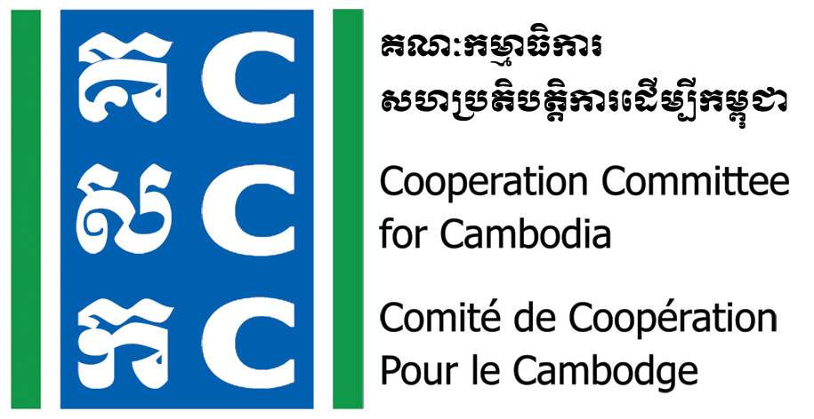

ទស្សនវិស័យៈ ការអភិវឌ្ឍប្រកបដោយនិរន្តរភាព និង ប្រជាធិបតេយ្យសម្រាប់ប្រទេសកម្ពុជា
Vision: Sustainable and democratic development for Cambodia

Do No Harm Post-Training of Trainers
Date: 22-23 November 2023
Venue: Phnom Penh (TBC)

Background:
The Cooperation Committee for Cambodia (CCC) is a leading membership organization with 186 Local and International Non-Governmental Organizations (NGOs) in Cambodia.
Do No Harm and Conflict Sensitive Programming was hosted by CCC with the financial supports from Bread for the World (BfdW) who is concerned about the impacts of NGO’s work on local conflict. Do No Harm (DNH) is one of the key working approaches of CCC’s Governance Hub Program (GHP).
The goal of the DNH/CS phase 3 (01 January 2021-31 December 2023) is Civil Society Organizations in Cambodia are enabled to avoid negative impacts in their development programs.
Objective:
- To strengthen the Do No Harm core trainers in order to improve the quality of training on DNH in their own organizations or communities.
Agenda:
Time | Activities | Facilitator
 | Day One
8:00 - 8:30 | Registration | CCC
8:30 – 9:00 | Welcome and Introduction | DNH Trainer
9:00 – 10:00 | Recall of Do No Harm concept & tools | DNH Trainer
10:00 – 10:30 | Break
10:30 – 12:00 | Share experiences of DNH training | DNH Core Trainer
12:00 – 1:30 | Lunch
1:30 -3:00 | Share experiences of DNH training | DNH Core Trainer
3:00 -3:30 | Break
3:30 – 5:00 | Reflection of DNH training  Wrap-up | DNH Trainer
 | Day Two
8:00 – 8:30 | Check-in and Reflect on Day 1 | DNH Trainer
8:30 – 10:00 | Practice on DNH training and feedback | DNH Trainer
10:00 – 10:30 | Break
10:30 – 12:00 | Practice on DNH training and feedback | DNH Trainer
12:00 – 1:30 | Lunch
1:30 – 3:00 | Practice on DNH training and feedback | DNH Trainer
3:00 – 3:30 | Break
3:30 – 5:00 | Next steps, Course evaluation, Certification | CCC

Noted: CCC reserves the right to alter the agenda depending on time constraints and availability of resource persons.

