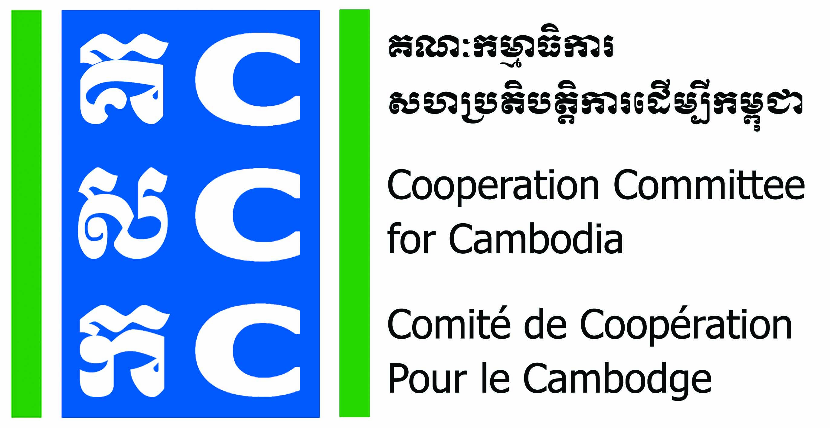
ទស្សនវិស័យៈ ការអភិវឌ្ឍប្រកបដោយនិរន្តរភាពនិងប្រជាធិបតេយ្យសម្រាប់ប្រទេសកម្ពុជា
Vision: Sustainable and democratic development for Cambodia

CALL FOR DO NO HARM APPLICATION WORKSHOP

- Background information
The Cooperation Committee for Cambodia (CCC) is a leading membership organization in Cambodia. By March 2022, CCC has 187 International and Local NGOs as members and networking with NGOs and CBOs in 16 provinces, working on different development sectors in the country. CCC has been playing a unique role since 1990 in strengthening cooperation professionalism accountability governance of CSOs for effectively and innovatively responding to development challenges in Cambodia.
Do No Harm and Conflict Sensitive Program (DNH-CSP) has been implemented by CCC since 2015 with financial support from Bread for the World (BfdW). DNH is one of the key working approaches of CCC’s Governance Hub Program (GHP). The current phase of DNH-CSP is a 3-year project from 01 January 2021 to 31 December 2023.
Goal of the program: CSOs in Cambodia are enabled to avoid negative impacts in their development programs.
In order to achieve this goal, CCC will organize 21 Do No Harm Application Workshops in 2023.
- Objective
Participated organizations use DNH tool to analyze their Strategy/Program/Project by: 1-analyse context of conflict in their workplace, identify Dividers and Connectors, 2-analyse patterns of impact from their intervention, 3-generate programming options, and 4-develop DNH framework.

- Topics of the course
Time | Day 1 | Day 2 | Day 3
Morning | Review DNH concept | Practice Step 2 & 3: Identify Dividers & Connectors. | Practice Step 5: Analyze Patterns of Impact.
Afternoon | Practice Step 1: Analyze context of conflict. | Practice Step 4: Unpack the Intervention. | Practice Step 6 & 7: Generate Options & Redesign Intervention.

- Methodology
The DNH Application Workshop will be organized separately for each organization to analyze their own program/project. If different organizations have similar project/program, they can join together if they wish and agree to do it.

- Scholarship for the DNH Application Workshop
CCC will provide 50% financially support on DNH trainer’s fee (Total trainer’s fee is 1,840$) to facilitate DNH Application Workshop at applicant organization.
The applicant organization will cover 50% of trainer’s fee and other logistic, materials, meeting room and participants’ expenses (if necessary).
- Timeline
Each DNH Application Workshop for individual organization will be conducted for 3 days in 2023 according to the agreed date with applicant organization.
- Registration:
For interested NGOs, please fill-in the attached application form and send to bunrithy.lav@ccc-cambodia.org by 15th of March 2023.

For more information, please contact:
Mr. Lav Bunrithy
Do No Harm Specialist
HP: 012 925 799
E: bunrithy.lav@ccc-cambodia.org

