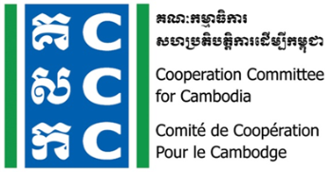
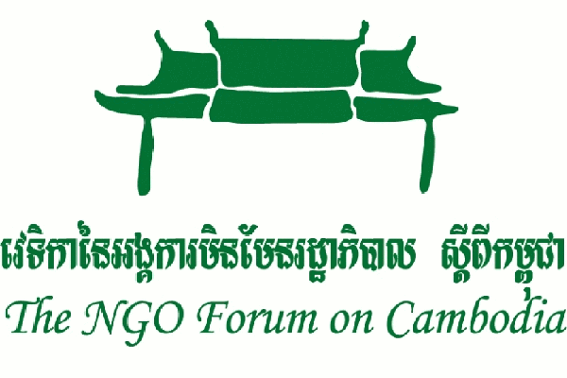

Joint Concept Note

Workshop to collect Inputs from CSO

for the Voluntary National Review (VNR) in 2023

Date: 24 January 2023

1. Rationale

At the United Nations Sustainable Development Summit on September 25th, 2015, world leaders adopted the Sustainable Development Goals (SDGs) to end poverty, protect the planet and ensure that all people enjoy peace and prosperity. SDGs is a collection of 17 new universal agenda by integrating three dimensions of sustainable development: the economic, social and environment.

The Government of Cambodia has finalized localization process of Cambodia Sustainable Development Goals (CSDGs) in late 2018. CSDGs has 18 Goals; including land mine clearance, 88 targets, and 148 indicators. Since 2013, civil society organization (CSO) has been playing a significant role in contributing the formulation and in supporting civil society organizations, development partners, as well as government for creation and localization of Sustainable Development Goals (SDGs) in Cambodia.

The Government of Cambodia will deliver a Voluntary National Review (VNR) Report at the 2023 session of the High-level Political Forum (HLPF) on Sustainable Development. The meeting convened under the auspices of the Economic and Social Council which will be held from 10 – 19 July, 2023 including the three-day ministerial meeting of the forum. The theme will be "Accelerating the recovery from the coronavirus disease (COVID-19) and the full implementation of the 2030 Agenda for Sustainable Development at all levels”. The set of goals to be reviewed in depth will be Goal 6,7,9,11 and 17. There are 41 countries, including Cambodia, will be making their voluntary national presentation at the HLPF. Cambodian government will produce the voluntary national review 2023 on the implementation of the 2030 Agenda for sustainable development.
2. Civil Society in Cambodia and the High-level Political Forum
Civil society organization plays a significant role in reflecting the progress and achievement as well as challenges of SDGs implementation through public feedback and Voluntary National Reviews in Cambodia. CSO holds some spaces to work in partnership with the government and other stakeholders on SDGs localization, specifically through the national Technical Working Group (TWGs) mechanisms, and the voluntary national reviews. One of the four of its engaged TWGs is the TWG on Planning and Poverty Reduction (PPR) which is co-chaired by the Ministry of Planning and UNDP in Cambodia and this TWG plays important role in developing key development agenda for the country, including the localization of the Sustainable Development Goals (SDGs).
Two key umbrella NGOs, including the Cooperation Committee for Cambodia (CCC) and the NGO Forum on Cambodia (NGOF), are the two NGO members of the TWG. The roles of CSOs through the TWG PPR and the active participation of CSOs during the SDGs formulation and localization process. Many workshops and consultations were led by CSOs and key suggestions were submitted to the government and other stakeholders.
Civil society organizations are active in holding policy-makers to account for the commitments they have made in an open, transparent and inclusive manner in VNR process. Civil society organizations use some spaces provided by the government to express their concerns and opinion in consultation workshop reflecting on the implementation of SDGs in Cambodia. Some Non-Governmental Organizations (NGOs) submitted their inputs for VNR report to Ministry of Planning, other line ministries, and the United Nations agencies in Cambodia.

3. Objectives
The objectives are the following:
- To represent the voice of civil society organization in Cambodia in the HLPF on reflecting the progress and challenges on the SDGs implementation in the Cambodia voluntary national review;
- To facilitate other leading sectoral civil society organization to share their findings on the thematic goals, especially SDG 6, 7, 9, 11, and 17, on the implementation of SDGs in Cambodia

4. Role of CCC and NGOF on the VNR Progress in Cambodia
Civil society organization plays a significant role on the implementation of SDGs and the voluntary national review (VNR) process. CSOs have been implementing four strategic plans on the Sustainable Development Goals (SDGs). The strategic plans are the following:
1). Raising awareness via public sensitization programs, especially among youth;
2). Building capacity development for program integration of SDGs and CSDGs among youth groups;
3). Promoting inclusive partnership with stakeholders (government, private sector and civil society) on financing for development and SDGs related policies prioritization and coherence; And
4). Reflecting the progress and achievements as well as challenges of SDGs and CSDGs implementation through public feedback and voluntary national review.

Cambodian government produce the voluntary national review 2023 on the implementation of the 2030 Agenda for sustainable development. CSO holds some spaces to work in partnership with the government and other stakeholders on SDGs localization, and the inputs are expected to share back to Ministry of Planning by the end Jan 2023. Committee for Cambodia (CCC) and the NGO Forum on Cambodia (NGOF) have been conducting workshop as the following agenda:

Time | Topics | Person in Charge
8:00 – 8:30 | Registration | Organizers and all participants
8:30 – 8:40 | Introduction and National Anthem | MC: Ms. Prak Koekongkea
8:40 – 9:00 | - Welcome remark  - Keynote remark | - Ms. Sin Putheary, Executive Director of CCC  - Dr. Tek Vannara, Executive Director of NGO Forum
9:00 – 9:10 | Opening Remark | Mr. Khoun Theara, Representative from UNDP
9:10 – 9:45 | Presentation: VNR 2023  - Background and Procedure  - High-level Political Forum  - Voluntary National Review 2023  Questions and Answers | Mr. Phim Runsinarith, a Consultant of UNDP
9:45 – 10:00 | Coffee Break | All
10:00 – 12:00 | Presentation on  The development/progress and challenges of implementation CSDGs goal 6, 7, 9, 11, 17  Speakers:  - SDG Goal 6: Mr. Ven Saroeut, Learning and Effectiveness Coordinator at WaterAid Cambodia.  - SDG Goal 7: Ms. Out Sokphalkun, Engagement Program Manager of Energy Lab.  - SDG Goal 9: Mr. Huon Pengsan, Youth Engagement Manager of Impact HUB  - SDG Goal 11: Ms. Pek Chiva, Project Manager of Sahmakum Teang Tnaut - STT  - SDG Goal 17: Mr. Son PenH, Executive Director of CPDD | Facilitator: Mr. Mar Sophal, Program Manager of NGO- Forum
12:00 – 1:30 | Lunch Break | All
1:30 – 3:00 | Group discussion for additional inputs (Progress, Challenges & Recommendation) and validation on SDGs/CSDGs Goals 6, 7, 9, 11, 17 and other related SDGs/CSDGs Goals | Facilitators: Mr. Mar Sophal, Program Manager of NGO Forum and Sar Mory, Policy, Legal and Advocacy Manager of CCC.
3:30 – 3:45 | Coffee break | All Participants
3:45 – 4:30 | Group presentation of the Progress, Challenges and Recommendations on SDGs/CSDGs goals 6, 7, 9, 11, 17 | All Participants
4:30 – 4:45 | Wrap-up | Mr. Phim Runsinarith, a Consultant of UNDP (TBC)

