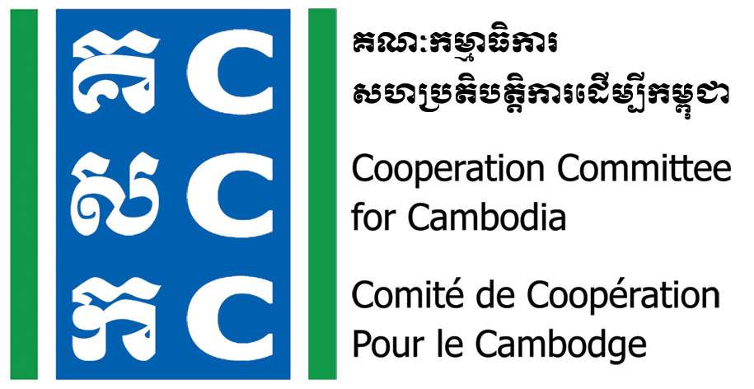
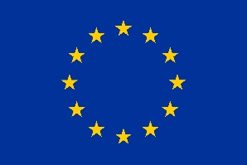

Terms of Reference
Consultancy Service for the Endline Evaluation
The Governance Hub Program (Phase IV) and the Project on Strengthening Civil Society for Democratic and Sustainable Development in Cambodia (Phase II)

- Introduction:

The Cooperation Committee for Cambodia (CCC) was established in 1990, and is registered with the Ministry of Interior. With its 32 years of operation in Cambodia, this is considered as the longest established and largest membership-based organization for NGOs in the country CCC currently has 188 NGOs as members, combining of both domestic and foreign bodies whose operation cover diverse development sectors in Cambodia. CCC has also established formal collaboration agreement with 16 provincial NGO networks, from different geographical representation. Additionally, CCC has extended its coalition with a number of civil society platforms, at both national and international levels.
With the adoption of program-based approach, CCC has been implementing a Governance Hub Program (GHP) since 2011 to contribute to its program goals and impact of resourceful, cooperative and capable development actors, particularly civil society, to accountably respond to development challenges in Cambodia. From 2021, CCC kicks start the implementation of its fourth phase Governance Hub Program (GHP 2021-2023). The program introduced one impact, two goals, four specific outcomes, 13 expected outputs and 50 indicators through which 65 key activities by adapting to its Theory of Change (GHP ToC 2021-2030) or Vision 2030.
To make its long-term roadmap more realistic and measurable, a three-year strategic plan (GHP 2021-2023) has been developed alongside the 10-year ToC of the organization. Proposed interventions for the next three years of fourth phase Governance Hub Program (GHP 2021-2023) contain one impact, two goals, four specific objectives, 50 indicators and 13 expected results through which 65 key interventions will be implemented from January 01, 2021 to December 31, 2023.
Alongside the implementation of this Governance Hub Program phase IV, CCC has also received a continued project from the EU called “Strengthening civil society for democratic and sustainable development in Cambodia” phase 2 which aims at producing three results: Enabling environment and democratic space enhanced for CSOs; 2. CSOs empowered with enhanced capacity, resiliency and representation; and 3. CSO Resources Hub formed at the national level. The project contains one impact, two goals, three specific objectives, 17 indicators and 6 expected results through which 27 key interventions will be implemented from July 01, 2021 o December 31, 2023. CCC, as the single implementer of the project, will ensure that full, relevant, and accurate information related to the project are available at the start of the project so that all changes and results produced by the project could be tracked and documented effectively.
So far, two monitoring and evaluation activities have been conducted for this specific project, including the baseline study of the project and the Result-Oriented Monitoring (RoM) of the project.​​ Findings from the two studies will be made available upon request.
Since the project​ and program will come to an end by December 2023, CCC will conduct an end line evaluation of the project to wrap up the achievements, challenges, lessons learned and related sustainability actions of the project, and to provide information and recommendations that is credible and useful for future decision and making processes. In this regard, CCC would like invite the consultant (team) who are interested and has applicable expertise to conduct this end line evaluation for the project.
- Program and Project’s Theory of Change
The GHP and the EU project have similar theory of change included one impact, two goals, and four specific objectives/outcomes as below:
Impact: Resourceful, cooperative and capable development actors, particularly civil society, to accountably respond to development challenges in Cambodia
Goals/Overall Objectives:
1). Improved enabling environment for CSOs and
2). Sustainability and functionality of CSO Resource Hub attained at the national and sub national level.
Specific Objectives/Outcomes:
1). CSOs are empowered with enhanced capacity and legitimacy,
2). The project contributes to enhance enabling environment and democratic space for CSOs,
3). Sustained and functional CSO’s Resource Hub at the national and sub-national levels and improve the sustainability/financial independency of NGOs
Primary beneficiaries of the GHP:
- All NGO members of CCC (176 NGOs counted by December 2020) and 500 people of their staff members (200 women).
- 400 NGOs of the 19 provincial NGO Networks and 500 people of their staff members (200 women).
- 100 CBOs from the 19 provinces and 150 staff members of those CBOs (50 women).
- 25 youth ambassadors whose capacity are carefully developed through the SDG Youth Ambassador project of CCC.
- 130 NGOs who are engaged in the GPP certification system as the Applicant NGOs and Interested NGOs. (Note: These target groups may be counted from 2022 if the full implementation of the new GPP modality cannot be made in 2021).
- 30 representatives from the Government – the Ministry of Interior (NCDD, ISAF, etc.), the Ministry of Economy and Finance (ACAR, GDT), CDC, the MoLVT, MoSVY, Arbitration Council, NSSF, MoP, the Ministry of Justice.
- 20 representatives from Development Partners – UNDP, UNV, E.U, USAID, NPA, DCA, UNRC, JICA, KOICA, Indonesia Aids, Diakonia, and Embassies.

Secondary beneficiaries of the GHP:
  - 800 NGOs including members of the 19 provincial NGOs networks and partners of CCC members and around 1,000 people of their staff members (400 women).
  - 300 (100 women) commune/district/provincial councilors.
  - 200 members from the National Assembly and authorities (local governors and line ministries) from 20 target provinces including Phnom Penh.
  - 15 companies/corporations from private sector who will be engaged through the interventions related to Corporate Social Responsibility (CSR), inclusive partnership dialogue, financing for development dialogues, SDGs dialogues etc.
  - 1200 CBOs from all target provinces and Phnom Penh.
  - 500,000 community people as members and beneficiaries of the target CBOs and NGOs from the 19 target provinces and Phnom Penh including women, youth, disabled people, LGBTIQ, IP, and other marginalized groups.
Logical frameworks for the GHP and project are attached with this ToR for reference purpose.
- Scope of Work

Specific Research Objectives:
The CCC Governance Hub Program phase IV (2021-2023) and EU project will end by December 2023, this study aims:
- To evaluate the current GHP program and EU project’s achievements and challenges, and to provide information and recommendations that is credible and useful for future decision-making processes for the new phase of the Governance Hub Program and the new project proposal.
- To identify significant success, areas of improvement, and lessons learnt and propose sustainability actions that shall be carried out after the project comes to an end.
- To provide to endline evaluation report for all of the indicators as stated in the logical frameworks of the program/project.

Key questions
- To what extent have the GHP and EU project achieved compared to the program and project indicators and objectives?
- To what degree are the program and project relevance, coherence, effectiveness, efficiency, impact, and sustainability?
  - Is the Governance Hub Program of CCC doing the right thing to respond to the CSO’s need and align with the donors and governmental strategies?
  - Does the GHP coordinate with others to avoid duplicated efforts? Any complementary or harmonization of intervention to add value while avoiding duplicated intervention?
  - Are the three objectives of the GHP being achieved and responsive to the needs of its members and beneficiaries?
  - Will the outputs and outcomes of the GHP be achieved in a timely and economically viable manner?
  - Will the GHP contribute to maintaining and enlarging the Civic Space in Cambodia and make changes in policy and legal framework?
  - Any unintended other positive or negative impacts/changes created by the GHP interventions?
  - Will the intended positive changes (foreseeably) have a lasting effect?
- To what extent should the project be improved for a possible future phase of the project?
- What are some good practices and lessons learnt that can be drawn from the project implementation?
- In what way does the program/project make a contribution towards gender equality?
- In what way does the program/project make contribution towards environmental impact?
- How do you ensure the protection of the rights of vulnerable people (eg. disability, minority, etc.) in the context of your program/project implementation?

Methodology:
The consultant (team) is suggested to employ desk review, qualitative and quantitation research methods to explore and validate the data, which could well respond to indicators and evaluation criteria that are stated in the project log frame matrix and in this Terms of Reference.
Type of beneficiary | # | Type of beneficiary | #
Member NGOs of CCC | 188 | CBO Core Trainer | 71
Non-member NGOs of CCC | 50 | CBO-SWG | 14
Learning Forum | 250 | Do No Harm-NGO | 130
National NGO Network | 11 | DNHC | 18
Provincial NGO Network | 16 | Development Partners | 20
GPP Community | 55 | Donors | 10
GPP-NCCC | 9 | National Government | 30
Youth Ambassador | 40 | Provincial Government | 16
LFR-NGO | 50 | CCC: MT and ExCom | 18
In principle, the end project evaluation will look at the performance of the program/project against the evaluation criteria (OECD/DAC). Additionally, the evaluation should also look at the visibility of the project and its stakeholders.
CCC will also provide relevant documents for the consultant (team) to be used as reference materials for the study. If necessary, further discussion on the methodology to be applied for the study could also be made between CCC and the consultant (team) to promote the quality of the study.

Timeline:
It is expected that this evaluation consultancy will be carried out between 24 February – 10 May 2023. CCC is expected to sign the consultancy contract by 24 February 2023.

Expected Results and Products:
The consultant (team) requested to deliver the results and products as below:
- Inception report
- Interim report
- Draft of the final report
- Debriefing/Presentation of the results
- Final report
A set of endline evaluation report (in English) for the Governance Hub Program and the project on the Strengthening Civil Society for Democratic and Sustainable Development in Cambodia. The report template needs to consider the quality of the report, the appropriateness and easy to understand format. The report should cover the following outline: Relevance, Coherence, Effectiveness, Efficiency, Impact, Sustainability, Inclusive partnership, visibility, lesson learnt, other elements and issues, and propose sustainability actions for relevant interventions in the future with the maximum page of 30.

Skills Knowledge & Experience:
The consultant firm or team with extensive knowledge and experiences:
- Knowledge and understanding of the situation of CSOs in Cambodia;
- Knowledge of Do No Harm and Conflict Sensitivity
- Knowledge and experiences in capacity development for organizational development;
- Knowledge of key national policies/laws such as LANGO, Taxation Law, Accounting and Auditing Law, Labour law, Cyber Law, National Strategic Development Plan (NSDP), Decentralization and Deconcentration (D&D), National Program on Sub-National Democratic Development Phase II (NP-2), National Social Protection Policy Framework (SPPF), Financing for Development, Cambodia Sustainable Development Goals (CSDGs), Development Cooperation and Partnership Strategy (DCPS) and other policy framework related to CSOs;
- Knowledge of multi-stakeholder initiatives such as Public-Private Partnership, Global Partnership on Effective Development Cooperation (GPEDC), Busan Agreement on Effective Development Cooperation and others.
- Award Criteria

The successful tender will be the one providing a high level of quality (for which it will be given a mark) with the lowest ratio of the total cost to the quality mark achieved. Tenders with a mark below 50% of available quality points will not be considered. The quality of the tender will be assessed as a function of the following criteria:
- Understanding of the Terms of Reference (20%)
- Appropriateness of the proposed methodology (50 %)
- Expertise and experience of the team (15%)
- Quality of planning of team member (15 %)

- Budget and Payment Schedule

The total available budget for this endline evaluation is available based on request. With this given budget, the consultant team is requested to submit an evaluation proposal which consists of appropriate study design and budget breakdown. The payment to successful consultant will be made with the following installment:

- 10 % when signing the contract and agreement on the inception report
- 30% when submitting completed questionnaire
- 30% when presenting the key findings
- 30% when the final report is endorsed
- Application Process

Interested candidates should submit an Expression of Interest (EOI) and Technical Proposal to the Cooperation Committee for Cambodia (CCC) by 10 February 2023 to: recruitment@ccc-cambodia.org The EOI should include: the proposed clear research methodology; budget; proposed relevant documents, detailed timeframe; and demonstrate how the applicant addresses the selection criteria. Applicants should also include a copy of their CV or team members CVs.
An orientation on the assignment will be provided to all interested candidates but only shortlisted applicants will be asked to attend an interview and provide written examples of their own research (in English).
For any further information, please contact:
- Ms. Luy Theary, Head of Program
H/P: 012 339 027 and e-mail: theary.luy@ccc-cambodia.org
Please refer to this link about GHP 2021-2023 and EU project document:
https://drive.google.com/drive/folders/1-1kD69kU9oLXyYmlazzNQDaP3ut1qhxk?usp=sharing

