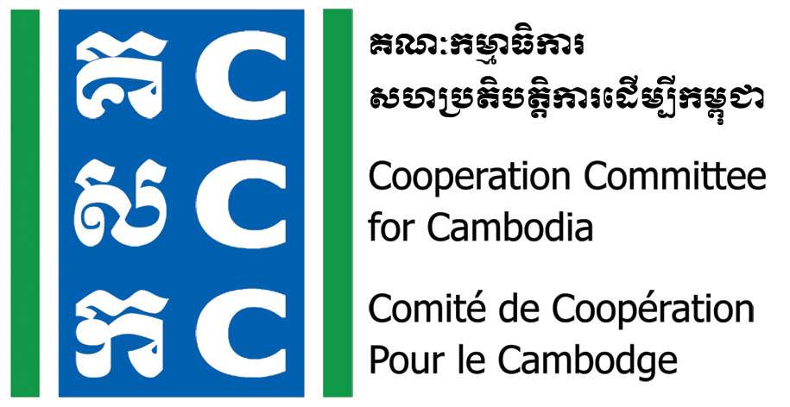

ទស្សនវិស័យៈ ការអភិវឌ្ឍប្រកបដោយនិរន្តរភាព និង ប្រជាធិបតេយ្យសម្រាប់ប្រទេសកម្ពុជា
Vision: Sustainable and democratic development for Cambodia

Do No Harm Community Practice Forum
22 December 2022

Background:
The Cooperation Committee for Cambodia (CCC) is a leading membership organization with 206 Local and International Non-Governmental Organizations (NGOs) in Cambodia.
Do No Harm and Conflict Sensitive Program (DNH/CS) is hosted by CCC with the financial supports from Bread for the World (BfdW) who is concerned about the impacts of NGO’s work on local conflict. DNH/CS is one of the key working approaches of CCC’s Governance Hub Program (GHP).
The Do No Harm Community of Practice Forum (DNH-CPF) is one of the activities of DNH/CS program organized twice a year to provide opportunity for sharing experiences among DNH/CS practitioners. The second DNH-CPF in 2022 will be organized on 22 December 2022 and expected there will be 70 participants to have a chance to meet together as the specific objective below.
Date & Venue:
- Date: 22 December 2022
- Time: 8:00 am - 05:00 pm
- Venue: Phnom Penh (location will be confirmed later)
Objective:
To document good practices, challenges and lessons learnt from DNH practitioners and organizations.
Target Participants:
- 2 staff representatives per organization who received DNH workshop
- Individuals who participated in DNH workshop and applied the concept
- Members of Do No Harm Cambodia (DNHC) Team.
Logistic Arrangement:
- Participation is free-of-charge
- Lunch, refreshment and materials will be provided by CCC
- Transport, per-diem and accommodation will be covered by participant’s organization
- Please register online through the provided link latest by 5:00 PM on 09 December 2022.

For more information, please contact:
Mr. Lav Bunrithy
Do No Harm Specialist
HP: 012 925 799
Email: bunrithy.lav@ccc-cambodia.org
Tentative Agenda
Time | Detailed Activity | Facilitator
8:00-8:30 | Registration | CCC
8:30-9:00 | - Welcome and Introduction | CCC
9:00-9:30 | Refresh on DNH framework/concept  (Why mainstream DNH in strategy/Program/Project?) | DNHC member
9:30-10:00 | Update on Do No Harm and Conflict Sensitive Program  - Key Achievements and Lessons Learned | Mr. Lav Bunrithy  DNH Specialist, CCC
10:00-10:30 | Break
10:30-12:00 | Panel Discussion:  Practical implementation of DNH in Project/Program  - Partner 1 (TBC)  - Partner 2 (TBC)  - DNHC member: experience from DNH application in Bangladesh.  Guiding Questions  - What did you learn in DNH workshop?  - What did you apply? How?  - What changes (positive and negative) can you observe as a result of the DNH application?  - Do you have any challenges in applying DNH?  - What was your lessons-learnt?  - Q&A (60mn) | DNHC member
12:00-1:30 | Lunch Break
1:30-3:00 | DNH in the context of human right/Advocacy work  Presentation:  - Does DNH is too soft to be applied alongside HR/advocacy?  Group Discussion:  - Where and how DNH support HR/Advocacy work? | DNHC member
3:00-3:30 | Break
3:30-4:45 | Next Step  - What did you learn from this forum? (1-2 point)  - What you will change or add in your project/program intervention?  - What support do you need (from DNHC team or others) in applying these learning? | DNHC member
4:45-5:00 | Summary and Closing | CCC/Representative of DNHC team

Noted: CCC reserves the right to alter the agenda depending on time constraints and availability of speakers. CCC will upload all documents, photos, and key activities and ideas in CCC websites, and social media for public access.

