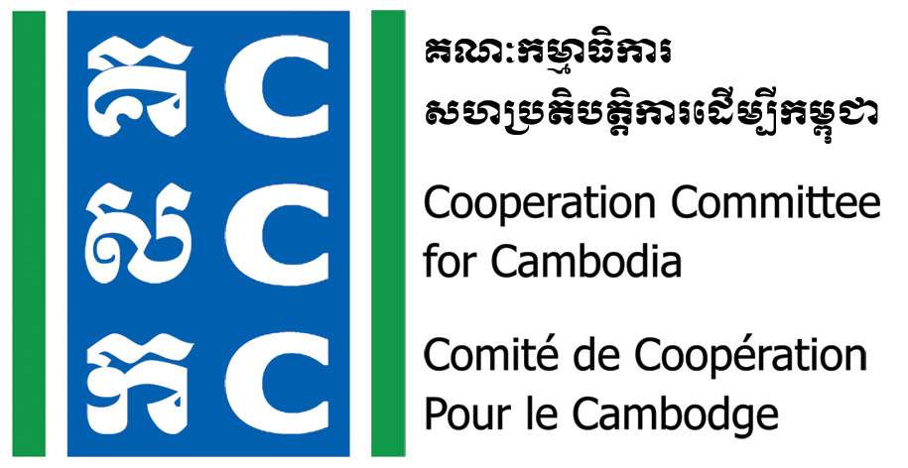

ទស្សនវិស័យៈ ការអភិវឌ្ឍប្រកបដោយនិរន្តរភាពសម្រាប់ប្រទេសកម្ពុជា
Vision: Sustainable development for Cambodia

Concept Note
Do No Harm Community Practice Forum
20 August 2019, @ Diakonia Center

Background:
The Cooperation Committee for Cambodia (CCC) is a leading membership organization with 206 Local and International Non-Governmental Organizations (NGOs) in Cambodia.
Do No Harm and Conflict Sensitive Programming was hosted by CCC with the financial supports from Bread for the World (BfdW) who is concerned about the impacts of NGO’s work on local conflict. Do No Harm (DNH) is one of the key working approaches of CCC’s Governance Hub Program (GHP) 2017-2021.
Within the second year of DNH and Conflict Sensitive program, 30 NGOs were conducted DNH Application Workshop and Coaching & Mentoring since 2017, so, the Community Practice Forum will be conducted for a full-day for full-trained organization. In total, there will be 70 participants from 30 trained NGOs to have a chance to meet together as the specific objective below.
Date & Venue:
- Date: 20th August 2019 (Full-Day)
- Time: 8:00am-17:00pm
- Venue: Diakonia Center, Phnom Penh (KSSA/ICF near Tuol Sleng Genocide Museum)
Google Map: https://goo.gl/maps/L5iPCQs3qDTVZrLi7
Objective:
There are three main objectives:
- To reflect on what they learned from the Application Workshop including process, methods, timing,…
- To share experiences of what they applied at their own organization
- To identify challenges of the application of DNH (from training to application/implementation) and possible solutions.
Target Participant:
The organization who already got DNH Application Workshop
- 2 staff representatives per organization who got DNH application workshop
- Members of Do No Harm Cambodia (DNHC) Team
Logistic Arrangement:
- Lunch, refreshment and material will be provided
- Transport, per-diem and accommodation will be covered by participant’s organization
Do No Harm Community Practice Forum
20 August 2019, @ Diakonia Center

Objective:
There are three main objectives:
- To reflect on what they learned from the Application Workshop including process, methods, timing,…
- To share experiences of what they applied at their own organization
- To identify challenges of the application of DNH (from training to application/implementation) and possible solutions.
Agenda
Time | Detailed Activity | Facilitator
8:00-8:30 | Registration | Ye Sokvutheavy
8:30-9:00 | Opening session:  - National Anthem  - Welcome and Introduction  - Welcome remarks by CCC | Ms. Ye Sokvutheavy  CMD Assistant  Mr. Soeung Saroeun  Executive Director, CCC
9:00-9:20 | Presentation: Do No Harm and Conflict Sensitive Program  - Introduction to DNH-CSP  - Key Achievements and Lessons Learned | Ms. Luy Theary  CD Manager, CCC
9:20-10:00 | Presentation: Brief introduction to DNH framework  (why DNH has been brought into the project implementation by donors?) | Ms. Menh Navy  DNHC Member
10:00-10:20 | Break
10:20-12:00 | Panel Discussion:  Practical implementation of DNH in Project/Program: it will be shared by 3 organizations (10mn/NGO)  - CHEC  - APLE  - STT  - DNHC member (Ms. Menh Navy/Ms. Chhoeun Thavy)  Guiding Questions  - What did you learn from DNH Application Workshop?  - What did you apply? Why? How? Any difficulty in applying?  - What changes or effect (positive and negative) can you observe as a result of the DNH application?  - What do you think are the factors (internal and external) for successful implementation of DNH in your organization?  - Lessons Learned  Q&A (60mn) | Dr. El Sotheary  Head of Program, CCC
12:00-1:30 | Lunch Break
1:30-3:00 | Presentation and Plenary Discussion:  How Do No Harm can minimize negative impacts of the project/program intervention?  - Presentation by DNHC member  - Question and answer  - Sharing experience by participants | Mr. Lav Bunrithy  VBNK and DNHC member
3:00-3:20 | Break
3:20-4:20 | Group Discussion  How to promote and disseminate DNH among stakeholders  - NGO community  - Donor  - Government | Ms. Luy Theary  CD Manager, CCC
4:20-4:45 | Next Step  - What did you learn from this forum? (1-2 point)  - What you will change or add in your project/program intervention?  - What support do you need (from DNHC team or others) in applying these learning? | Ms. Luy Theary  CD Manager, CCC
4:45-5:00 | Summary and Closing | Representative of DNHC team

Noted: CCC reserves the right to alter the agenda depending on time constraints and availability of speakers. CCC will upload all documents, photos, and key activities and ideas in CCC websites, and social media for public access.

